SOUTH KAZAKHSTAN PEDAGOGICAL UNIVERSITY NAMED BY U. ZHANIBEKOV
Muratova M.A. Artykbayeva F.I. Hamza B.N.


“USEFUL VOCABULARY WITH WORKSHEETS”

Shymkent - 2024

SOUTH KAZAKHSTAN PEDAGOGICAL UNIVERISTY named after OZBEKALI ZHANIBEKOV
Muratova M.A. Artykbayeva F.I. Hamza B.N.

“USEFUL VOCABULARY WITH WORKSHEETS”
педагогикалық білім беру бағдарлама бойынша білім алушыларына «Шетелі тілі» пәніне арналған оқу - әдістемелік құралы.

Өзбекәлі Жәнібеков атындағы Оңтүстік Қазақстан педагогикалық университетінің Академиялық кеңесінде қаралып баспаға ұсынылды. Хаттама № _____, ______ж.

Құрастырған : Мұратова М.Ә.
Артықбаева Ф.І.
Хамза Б.Н.

Пікір берушілер:
Құдайбергенова М.Р. - Ө. Жәнібеков атындағы ОҚПУ филология факультеті шетел тілдері кафедрасының аға оқытушысы, п.ғ.к.
Маханова Ж.К. – Ө. Жәнібеков атындағы ОҚПУ филология факультеті шетел тілдері кафедрасының аға оқытушы, Phd
Керимбаев А.Е. – к.ф.н. старший преподаватель кафедры “Языки и литература”, Центрально Азиатский Иновационный унвеситет

“USEFUL VOCABULARY WITH WORKSHEETS” оқу құралы педагогикалық мамандықты таңдаған жоғарғы оқу орындарының студенттеріне «Шетелі тілі» пәнінен өз бетінше немесе оқытушының басшылығымен жұмыс жасау үшін арналған.

АЛҒЫ СӨЗ

Ұсынылып отырған оқу құрал жоғары оқу орындарының білім алушыларына және өз бетімен ағылшын тілін үйренушілерге арналған. Оқу әдістемелік құрал оқу типтік бағдарламаға сәйкес жасалған. Ағылшын тілінде cөздерді мәтін оқу арқылы немесе әр түрлі жаттығуларды орындау арқылы сөздік қорын байыта алады. “USEFUL VOCABULARY WITH WORKSHEETS” атты оқу құралы тілдің негізгі заңдылықтары мен сөздерді жеңіл игеруге мүмкіндік жасайды. Лексикалық жаттығулар ережелерге сәйкес қарастырылған. Жаттығуларда берілген сөйлемдер құрамы жеңіл лексикамен мағыналары түсінікті тілмен құрастырылған. Лексикалық жаттығуларды мамандықта созылмайтын білім алушылардың өздік жұмысы ретінде қолдануға болады. Әрбір жаттығуды орындағанда лексикалық ерекшеліктеріндегі ережелерді ескере отырып жасаған ыңғайлы. Сонымен қатар Лексикалық жаттығулар жинағын, қазақ, орыс тілінде оқитын оқу орындарында пайдалануға тиімді. Келесі тақырыптарды қамтиды:
1.Me and my family
2. Modern young family
3. Relations between representatives of different generations
4. My house is my support
5. Human and his health
6. Sport in human life
7. Spending free time
8. World map
9. Geographical location and boundaries
10. Attractions of the city
11. The customs of the Republic of Kazakhstan and the country where the language is taught
12. Cultural and national holidays
13. My knowledge
14. My university
15. Future profession

- ME AND MY FAMILY

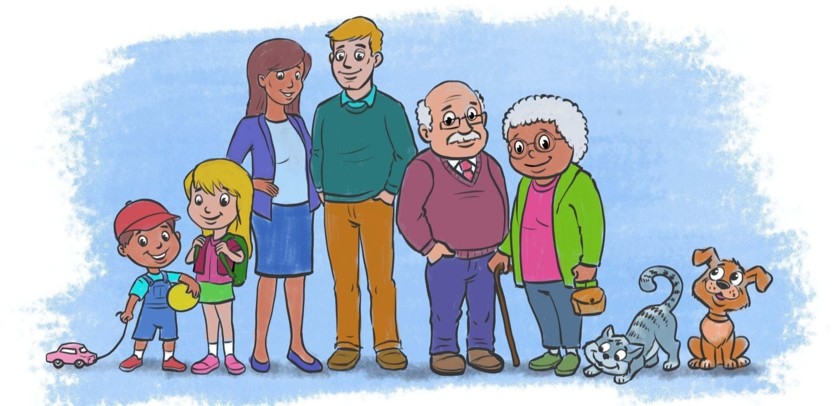
Activity 1
Text: Read and translate
Lily and her Wonderful Family

Hello, everyone! I’m Lily, eight-year-old from Australia. I’m excited to share a bit about my awesome family with you!
My mom is Sarah, and she has curly red hair. She really makes the best pancakes. My dad, James, is tall and enjoys telling funny jokes. He’s very funny. We often have family laugh sessions!
In our family, there’s my older brother, Jake. He is eleven and loves playing soccer. Then, there’s my little sister, Mia. She is just four years old. Mia loves her teddy bear, Benny, and takes him everywhere.
We have fantastic aunts and uncles too! Aunt Emily, my mom’s sister, is a painter, and Uncle Alex, my dad’s brother, is a chef. They always make our family gatherings lively.
Grandma and Grandpa are the best. Grandma bakes delicious cookies, and Grandpa tells fascinating stories about the past. I also have three cousins, Sophie, Max, and Liam. We often have fun playing board games together.
And, of course, I have a fluffy pet bunny, Cotton. She loves playing in the backyard and eating carrots.
I feel so lucky to have such a wonderful family and a furry friend like Cotton!
Vocabulary:
Family members
- Brother – аға
- Sister – әпке
- Mother – ана
- Father – әке
- Grandmother – апа/әже
- Grandfather – ата
- Uncle – көке
- Aunt – тётя
- Cousin – двоюродный брат/сестра
Marital relationships
- Husband – муж
- Wife – жена
- Spouse – супруг(а)
- Marriage – брак
- Divorce – развод
- Wedding – свадьба
- Engagement – помолвка

Родственные отношения
Family relationships
- Parent – родитель
- Child – ребенок
- Son – сын
- Daughter – дочь
- Sibling – брат/сестра
- Half-sibling – сводный брат/сестра
- Stepbrother – сводный брат
- Stepsister – сводная сестра
- Stepmother – мачеха
- Stepfather – отчим

Родственные связи
Family ties
- Blood relation – кровное родство
- In-law – связанный браком
- Relative – родственник
- Nephew – племянник
- Niece – племянница
- Grandson – внук
- Granddaughter – внучка
- Great-grandparent – прабабушка/прадедушка
- Godfather – крестный отец
- Godmother – крестная мать
1. Родители (Parents)
Родители являются главными руководителями и заботятся о своих детях.
- Mother – мать
- Father – отец
- Parental responsibilities – родительские обязанности
- Provide emotional support – обеспечивать эмоциональную поддержку
- Teach life skills – учить жизненным навыкам
2. Дети (Children)
Дети являются членами семьи, которых родители воспитывают и заботятся о них.
- Son – сын
- Daughter – дочь
- Obey parents – повиноваться родителям
- Help with household chores – помогать по дому
- Respect elders – уважать старших

Activity 2: Family Tree

Instructions: Draw your family tree below. Label each family member with their relationship to you (e.g., mother, father, sibling, etc.). Include as many family members as you can.

Activity 3: Family Vocabulary

Instructions: Match the family member term with its correct definition.

____ Mother
____ Father
____ Sister
____ Brother
____ Grandparent
____ Cousin
____ Aunt
____ Uncle
Definitions:
a) The female parent of a child.
b) The male parent of a child.
c) A female sibling.
d) A male sibling.
e) The parent of one's parent.
f) The child of one's aunt or uncle.
g) The sibling of one's parent.
h) The sibling of one's parent of the opposite gender.

Activity 4: Describe Your Family

Instructions: Write a short paragraph describing your family. Include information about your family members, their roles, and any special traditions or activities you do together.

Activity 5: Family Interview

Instructions: Interview a family member (e.g., parent, grandparent) and ask them the following questions. Write down their answers.

What is your favorite family memory?
What is something you admire about our family?
What are some family traditions you enjoy?
What is one piece of advice you would give to our family?
[Question Space] [Answer Space]
Activity 6
Vocabulary worksheet, fill the gaps

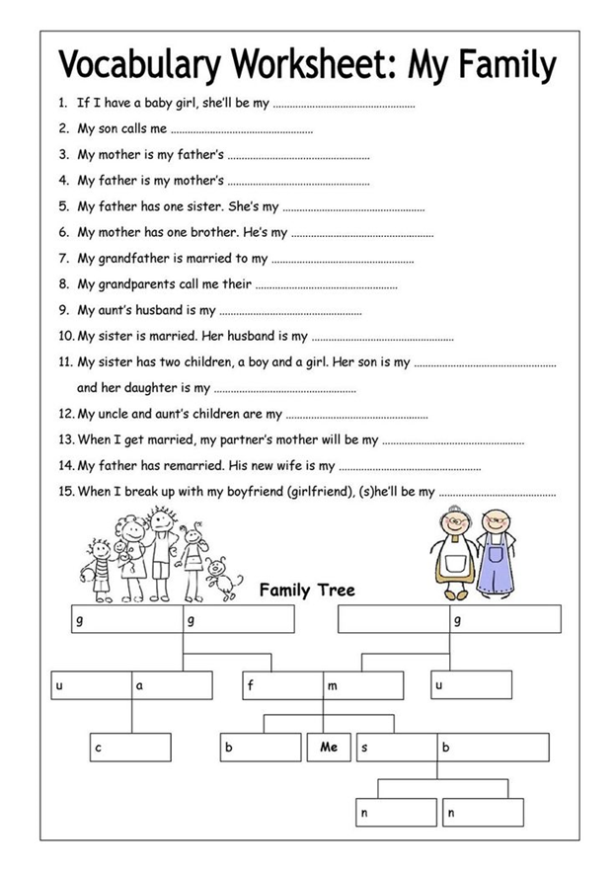
- MODERN YOUNG FAMILY


Activity 1 Read the text and translate it: Modern Young Families
In today's society, modern young families face a myriad of challenges and opportunities as they navigate the complexities of contemporary life. Unlike previous generations, where traditional family structures predominated, modern young families often exhibit unique characteristics shaped by societal shifts, economic realities, and evolving cultural norms.
One notable trend among modern young families is the prevalence of dual-income households. With the rising cost of living and economic pressures, many couples find it necessary for both partners to work outside the home to support their family financially. This dynamic has redefined traditional gender roles, as women increasingly participate in the workforce and men take on greater responsibilities in the home.
Another defining feature of modern young families is the phenomenon of delayed marriage. Unlike their parents or grandparents, who often married in their early twenties, today's young adults are waiting longer to tie the knot. This delay is attributed to various factors, including pursuing higher education, establishing careers, and prioritizing personal fulfillment before committing to marriage and parenthood.
In terms of parenting, modern young families often embrace a more egalitarian approach known as co-parenting. Regardless of whether the parents are in a romantic relationship, co-parenting emphasizes shared responsibility and collaboration in raising children. This approach allows both parents to actively participate in childcare and decision-making, promoting a more balanced and supportive family environment.
However, modern young families also face challenges in maintaining work-life balance. Juggling the demands of career and family can be overwhelming, leading to stress and burnout for many individuals. Balancing professional obligations with personal time for relaxation, recreation, and quality family interactions is essential for the well-being of both parents and children.
Furthermore, technology plays a significant role in the lives of modern young families. From smartphones and social media to streaming services and online learning platforms, technology permeates every aspect of daily life. While technology offers convenience and connectivity, excessive screen time can detract from face-to-face interactions and family bonding, posing challenges for maintaining healthy relationships within the family unit.

Despite these challenges, modern young families also enjoy unique opportunities for personal growth, fulfillment, and connection. By embracing diversity, adapting to change, and fostering open communication, modern young families can thrive in today's dynamic and ever-changing world.
Comprehension Tasks:
Activity 2
Multiple Choice Questions:
a. According to the text, what is a notable trend among modern young families?
- Single-income households
- Delayed marriage
- Traditional gender roles
- Parenting without collaboration
b. What does co-parenting emphasize?
- Shared responsibility and collaboration
- One parent taking full control
- Following traditional gender roles
- Parenting only within a romantic relationship
Activity 3
True or False:
State whether the following statements are true or false according to the text:
- Modern young families often prioritize marriage and parenthood at a younger age than previous generations.
- Balancing work and family life is not a concern for modern young families.
- Technology has no impact on the lives of modern young families.
- Co-parenting encourages both parents to actively participate in childcare.
Activity 4
Discussion Questions:
- What are some of the challenges modern young families face in today's society?
- How do you think technology affects family dynamics in modern households?
- What strategies can modern young families use to maintain a healthy work-life balance?
- Do you believe delayed marriage is a positive or negative trend for modern society? Why or why not?
Activity 5
Try to understand the words meaning and memorize
- Dual-income: A family in which both partners or spouses are employed and contribute to the household income.
- Delayed marriage: The trend of couples choosing to marry at a later age than previous generations, often after completing their education and establishing careers.
- Co-parenting: A parenting arrangement in which both parents actively participate in raising their children, regardless of whether they are in a romantic relationship.
- Gender roles: Societal expectations and norms regarding the behavior, responsibilities, and attributes deemed appropriate for individuals based on their gender.
- Work-life balance: The equilibrium between professional responsibilities (work) and personal life (family, leisure, and self-care), allowing individuals to meet their obligations and pursue their interests.
- Parenting styles: Different approaches or methods that parents use to raise and discipline their children, influenced by their beliefs, values, and cultural background.
- Technology use: The integration of digital devices and online platforms into daily life, including communication, entertainment, and information-seeking behaviors within the family context.
- Intergenerational relationships: Relationships between individuals from different generations within a family, encompassing interactions, communication patterns, and the exchange of knowledge and experiences.
Activity 6
Translate the words
# | Words | Translation
1 | Dual-income
2 | Thriving
3 | Adapting
4 | Well-being
5 | Supportive
6 | Opportunities
7 | Challenges
8 | Flexibility
9 | Connectivity
10 | Collaboration
11 | Diversity
12 | Delayed marriage
13 | Co-parenting
14 | Work-life balance
15 | Gender roles
16 | Technology use
17 | Egalitarian
18 | Stress
19 | Burnout
20 | Communication

Activity 7
Make up sentences by using the vocabulary

3. RELATIONS BETWEEN REPRESENTATIVES OF DIFFERENT GENERATIONS



Activity 1

Read and retell the text: GENERATION GAP IN THE 21ST CENTURY
At the present stage of development of society there is a rift between generations. Socially significant is the sphere of interpersonal communication, as interpersonal communication makes possible the accumulation and transfer of social experience, and transmission of culture from one generation to the following. The attitude of youth to older people can be considered as one of the indicators of the cultural level of society. Stereotypical statements and opinions relating to old people are indicators reflecting the main cultural circle of the concepts in a given epoch. In our times there is a cult of youth. Human dignity is determined by the ability to quickly and effectively, easily adapt to new technologies and innovations. For example, now we can hear such allegations of young people: ” older generation do not understand us at all. It is quite clear, as they’re from the last century.” These phrases suggest that parents, and especially the elderly can not keep up with progress and progressive ideas of modern times.
Misunderstanding between the generations affect confusion of ideas, culture (all aspects of culture, such as music, literature, fashion, etc.), technologies and even the very way of life. Over the past decade life has changed so rapidly that today’s youth of the early 21th century, and their parents as the generation of 70-80’s have almost nothing in common. In this case, the younger generation blames seniors in “backlog.” New fashion, information space based on Internet technologies, social networks, mobile phones, is not understandable to many older people. The cult of innovation technologies and progress (when you must be aware of the latest trends in the computer technologies) is not understandable to older people. In turn, youth can not always understand the value of traditional literature, art, theatres and museums – all these values are seen as old and unnecessary, which lost their actuality in the 21st century.
But the greatest problem related to this can be called the negative attitudes towards the old age itself. Older people do not keep pace of modern life, do not have the strength to carry out various kinds of responsibilities and roles that brings new life, they are drowning in the chaos of information. Society nowadays faces with the growing problem of old age due to the growth of life expectancy. In terms of relations of generations, the world is experiencing a unique historical period, the essence of which lies in the fact that the society was first formed of few-generations structure, and it caused a number of extraordinary, in terms of traditional processes of socialization, effects.
At the beginning of this century the social culture of the society has changed dramatically. The sharp cultural discontinuity, which occurred as a result of development of market relations, has led to a certain social isolation of older people, to the loss of their status and respect. The most important in intergenerational relationships becomes the ability of each generation to adapt, to form a single social and cultural space without rigid hierarchy, without violence, disrespect of the “fathers” to the children, with an authority of the elderly, and trust and love to the growing generation. To learn to understand each other is an important social challenge.
alking about the influence of the older generation on youth, we must emphasize the importance of this factor as a measure of trust between youth and seniors. The family is the first and most important aspect in relations between different generations. The absence of appeals for help of youth in crisis situations shows the desire of young people to independent problem-solving on their own. Even mothers as the closest persons are not involved in the life of her children today, her role as a helping person is given to peers. This situation confirms the general trend of our society’s transition to a new stage, when the peers are the main source of information and supportive help in dealing with individual problems. It is fraught with weakening of intergenerational relationships, the difficulty of translation and the perception of past experience. Currently, the family undergoes cultural, social and economic changes, that affect the family relationships. Since family ties are not so important, the elderly become useless and forgotten by young generation.
But it is important to note that the older generation performs an important social function of the connection between generations, as a necessary link in the chain leading from the distant past. The memory about the past today is accumulated in books, film documents, on CD-ROM, and in the memory of the elderly. Nowadays even within the family does not occur the transmission of family traditions from the older to the younger generation, the memory of ancestors. Today is becoming the norm when many young people can not name the places of work and positions of their father or mother, not to mention biographies of parents, especially of grandparents. Such indifference of the younger generation to the past is a new reality of our time.
The problem of generations is an old one, but it becomes particularly acute in the 20th century and early 21st century, when rapid progress and development of all spheres of life of the society has led to a gap between different generations. The difference in attitudes, tastes, values and life orientations is the cause of misunderstandings, indifference and even negative attitudes and conflicts between generations.

Activity 2 Try to analyze the picture and what do you understand from the picture
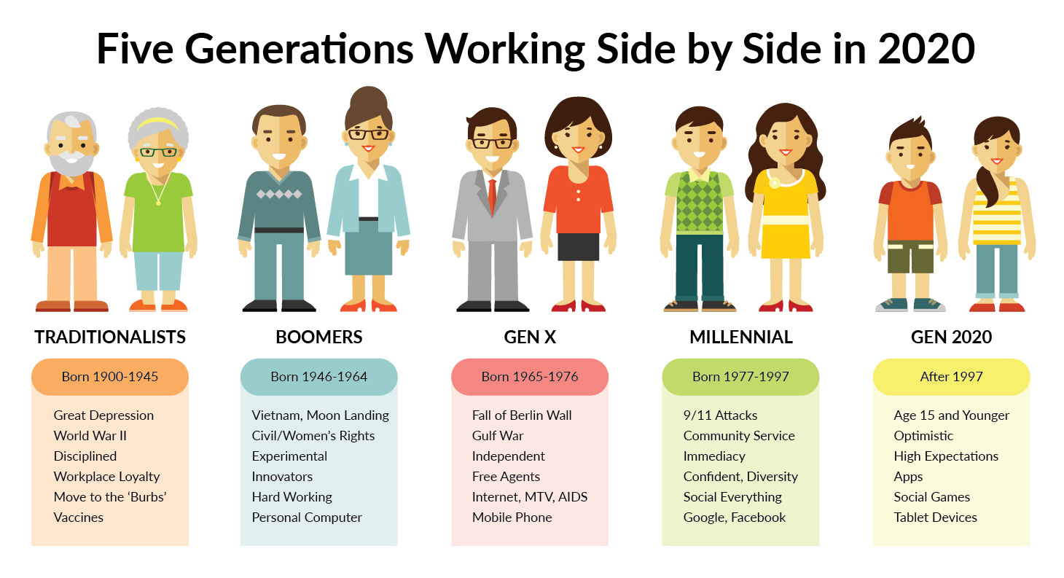

Activity 3 Read and add your own opinions or views to the text: Conflict between generations
The twentieth century has noticeably worsened relations between generations. The problem of continuity and conflict in relations of “fathers” and “children” can be viewed as the interaction of different situations and activities, especially due to the transmission of cultural values from generation to generation. This problem has always existed, but the content of the problem and acuteness of the contradictions is especially strong in 20th and early 21th century. This is primarily due to the ultra-fast development of society, a situation when we see not just “progress” in all spheres of public life, but the “revolution”. And of course this fast development leads to a widening gap between generations. Now different generations do not understand each other, it is difficult to overcome differences and gap in so rapidly changing lifestyles, attitudes, and “chase” the speed of progress in modern society. This is not just a problem of misunderstanding, and it carries much more negative effects. In modern society, we have
transformation of the relationship of younger age groups for the older generation in the direction of the traditionally deferential to the unconventional condemn and reject. In such circumstances, older people become abandoned by new generation, deprived of compassion, empathy, understanding and support from younger members of the society. To learn to understand each other, especially the older generation, – is an important social problem of modern society.
Activity 4
Write down the definitions of the words

# | Words | Definitions
1 | Generational Gap
2 | Respect
3 | Understanding
4 | Communication
5 | Tradition
6 | Values
7 | Experience
8 | Technology
9 | Wisdom
10 | Adaptability
11 | Conflict
12 | Harmony
13 | Sharing
14 | Learning
15 | Empathy
16 | Appreciation
17 | Support
18 | Patience
19 | Diversity
20 | Legacy

Activity 5
Make up 5-8 sentences according to the words below

4. MY HOUSE IS MY SUPPORT

- Activity 1
Text: Read and translate 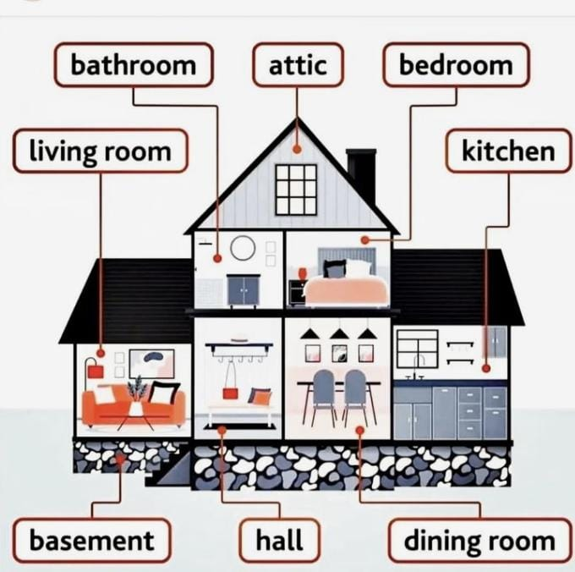
My dream house
My dream house is a mansion.There is a ground floor, a first floor, an attic and a basement.There are two bedrooms, two bathrooms, a kitchen, a study, a toilet, a living room, a dining room, a garden, a garage, a Jacuzzi, a swimming-pool, a water park,a playground and a dog house.
In the bedrooms there are beds, three bedside tables, wardrobes and a bookcase. In the bathroom there is a bath, a washbasin, a mirror, a rug and a toilet. In the other bathroom there is a shower, a basin, a mirror, a rug and a toilet. In the basement there is wash machine and bicycles. In the attic there are toys, books and a trunk with things. In the kitchen there is a cooker, a fridge, a sink, a dishwasher, a microwave, a cupboard and a toaster. In the study there are two computers, three desks, three chairs and five bookcases with books. In the toilet there is a toilet, a basin and a mirror. In the living room there is a cupboard, a sofa, a coffee table and two armchairs. In the dining room there is a big table, twelve chairs and a cupboard. In the garage there are two cars and a motorbike. In the water park there is a black hole and big water slides. In the playground there is a seesaw, a swing, a slide, a sandbox and a beautiful tree house on the big tree.
My favourite room is my living room. I love my mansion.
- Activity 2
MY HOUSE
Hi. My name is Sammy. My family is at home. I'm in my bedroom doing my homework and listening to music. My sister and my father are in the living room. My sister is drawing a picture and my father is watching TV. My mother is in the kitchen, and she is cooking dinner. My brother is in the bathroom. He is having a bath.
1. Read and write Yes or No:
a. Sammy is in the living room. -------------------
b. The father is sleeping in the bedroom. -------------------
c. The sister is drawing a picture in the living room. -------------------
d. The mother is in the kitchen. -------------------
e. The mother is cleaning in the kitchen. -------------------
f. The brother is in the bathroom. -------------------
g. The brother is playing football. -------------------

2. Answer the questions:
a. Where is Sammy?
---------------------------------------------------------------------------------
b. What is the mother doing?
-----------------------------------------------------------------------------------
c. What is the sister doing?
-----------------------------------------------------------------------------------
d. What is the brother doing?
------------------------------------------------------------------------------------

Vocabulary:
1.Flat- квартира
2.House- дом
3.Semi-detached house- два дома, соединённые общей стеной
4.Front door- входная дверь
5.Staircase- лестница
6.Roof- крыша
7.Garden- сад
8.Garage- гараж
9.Chimney- труба
10.Aerial- антенна
11.Nursery- детская
12.Bedroom- спальня
13.Bathroom- ванная
14.Kitchen- кухня
15.Living room- гостиная
16.Study- кабинет
17.Toilet- туале
- Bedroom
1.Bed- кровать
2.Pillow- подушка
3.Pillow-case- наволочка
4.Blanket- одеяло
5.Wardrobe- гардероб
6.Alarm clock- будильник
7.Chest of drawers- комод
8.Hair dryer- фен
Living-room
1.Cushion- диванная подушка
2.Bookcase- книжный шкаф
3.Ceiling- потолок
4.Furniture- мебель
5.Carpet- ковёр
6.Arm-chair- кресло
7.Sofa- диван
8.Painting- картина
9.Wallpaper- обои
10.Fireplace- камин
11.Lamp- лампа

Activity 3
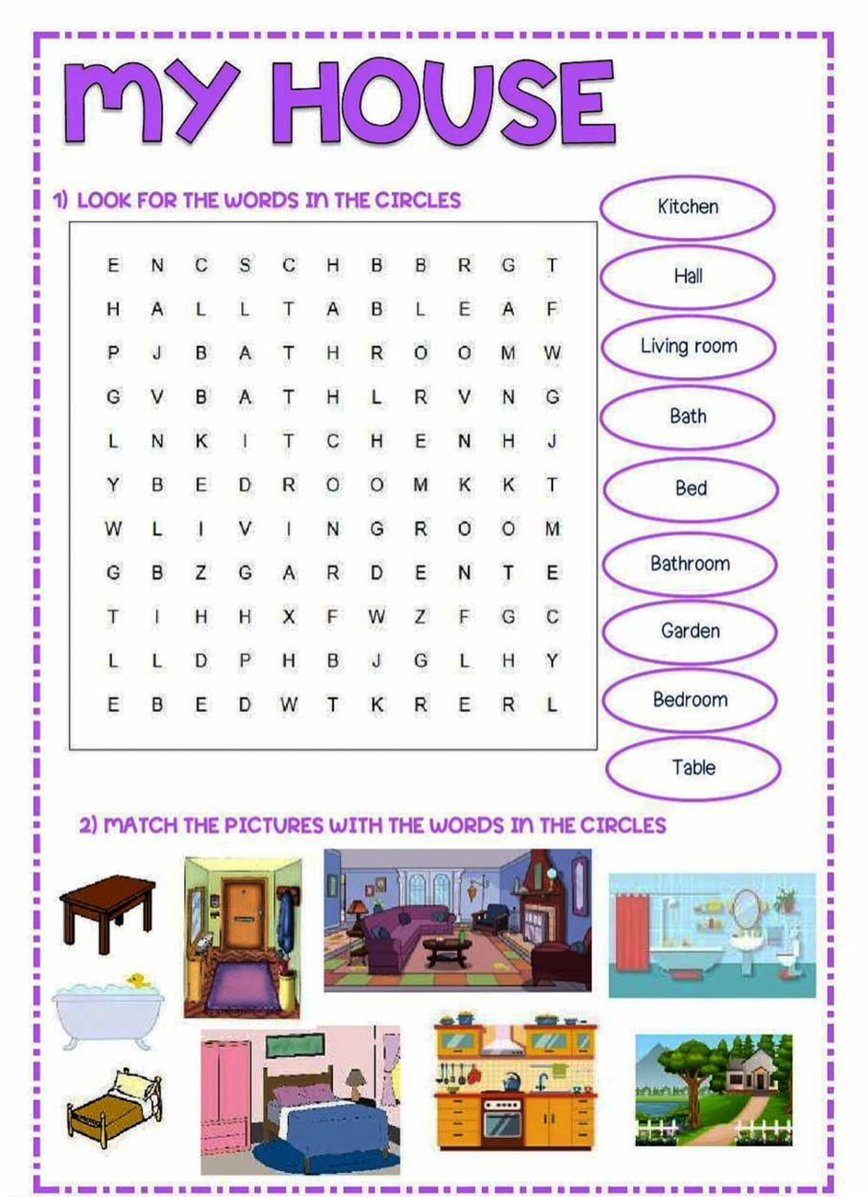

Activity 4
What are they doing?
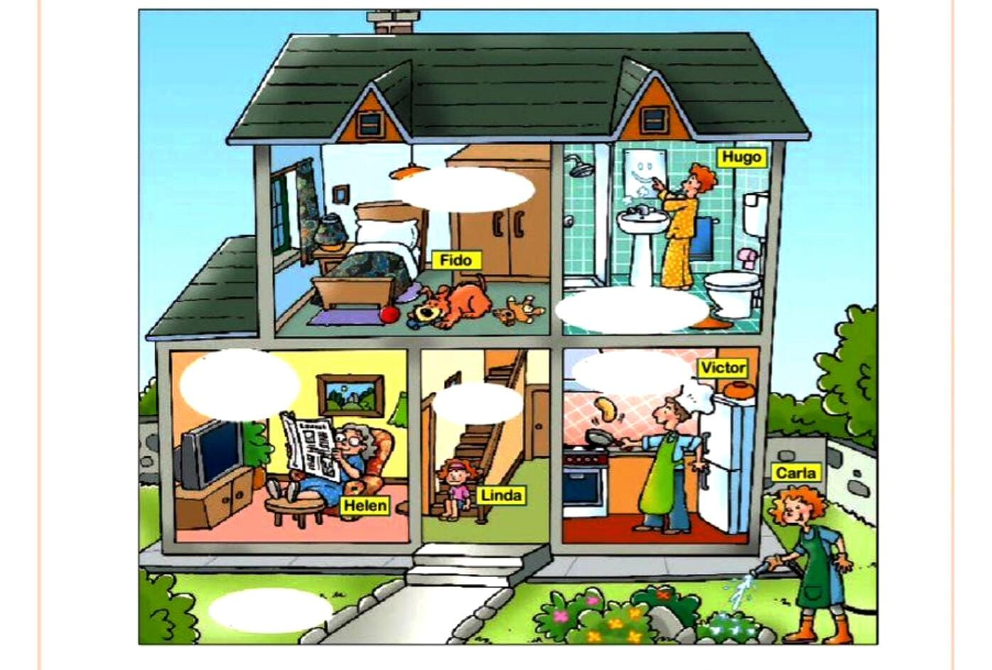
A. Label the parts of the house. Then choose TRUE or FALSE
1. He Victor is in the garage. TRUE FALSE
2. Victor is in the garage. TRUE FALSE
3. Carla is in the garden. TRUE FALSE
4. Hugo is in the bathroom. TRUE FALSE
5. Linda is in the kitchen. TRUE FALSE
6. Fido is in the bedroom. TRUE FALSE

B. Look at the picture and then write sentences about what they are doing.
1. Hugo ---------------------------------------------------------------------------------------------
2. Helen ---------------------------------------------------------------------------------------------
3. Victor ---------------------------------------------------------------------------------------------
4. Carla-----------------------------------------------------------------------------------------------
5. Linda -----------------------------------------------------------------------------------------------
6. Fido--------------------------------------------------------------------------------------------------

Activity 5
MY HOUSE
- 1.Read and write 1, 2 or 3 corresponding to the three houses in the passage.
I have a beautiful double bedroom available in an apartment to share with one other
person. The apartment is on the 12th floor and the room itself is a large double
bedroom with two big beds under the window. There is a lamp and a chest of drawers
between the two beds. In the corner of the room, there is also a wardrobe and a
bookshelf. The apartment has a modern kitchen and an open living room. It is only a 5-
minute walk to the bus stop. A one month deposit is needed, but there are no other
fees.
2.We have a large unfurnished double room, in a really nice house in the city. It's a big
and clean house with a beautiful street view. The house is a 10-minute walk from the
station. There is a shared living room, bathroom and kitchen with an air-conditioner,
two ceiling fans, a microwave, a television and four armchairs. The minimum term is
three months and the deposit is one month's rent.The room is in a two bedroom house
that is very close to the bus stop going to the town. There is a kitchen next to the room
and it's furnished including a dishwasher. There are also two large modern bathrooms
with separate showers. The room is facing the garden and it is nice and quiet. It's good
for people who enjoy a quiet but sociable life. The house is occupied by a mother and
her 10-year-old son. Both are very nice and friendly. The rent is all inclusive - no more
charges.

---------------------------- There are 2 beds in the bedroom.
---------------------------- It is very near the bus stop to the town.
---------------------------- You must rent it at least 3 months.
---------------------------- You will live with another person if you rent this house/ apartment.
---------------------------- There isn't any furniture in this room.
---------------------------- The kitchen is next to the bedroom.
---------------------------- There are two bedrooms in this house/ apartment.
---------------------------- You will live with a woman and a boy in this house/ apartment.
----------------------------- It takes you about five minutes to walk to the bus stop.
----------------------------- You will share the bathroom and the kitchen with others.

5. HUMAN AND HIS HEALTH



Activity
Text: Read and translate
Human and his health
* Good health is very important for every person. Moreover, there is nothing more important than health. Wise people even say: "Health is above wealth", because if you don't care of your health, you can't study or work properly. Unfortunately, having perfect health is almost impossible nowadays. Due to highly polluted environment people suffer from many diseases.
* The best way to stay healthy is to do regular morning exercise, to eat healthy products, to sleep at least 8 hours a day and to quit bad habits. The good thing is that people are becoming more health-conscious. In my opinion, the number of smoking and alcohol drinking people is decreasing in our country. This is happening because people started to understand how dangerous these two bad habits are. Obesity is another health problem. People, who eat lots of fattening food and do almost no exercise, are often overweight.
* A healthy diet involves many fruit and vegetables, seafood and wholegrain products. Salt, sugar and fat should be avoided. Excessive dieting can be also dangerous.
* Some people refuse to eat meat and become vegetarian. However, doctors say that meat is an excellent source of good nutrition.
* To my mind, one of the best ways to stay healthy and fit is to go in for various sports. It is especially useful to go for a walk before going to bed.

Activity 2
THE TASK FOR THE TEXT

*1 What is in your opinion can strengthen the immune system?

* 2What sport do you do? Does it help to be healthier?

* 3What do you think about vegetarianism?

Activity 3
True or False

A) The food that you eat does not affect your health.
B) Unfortunately, having perfect health is almost impossible nowadays.
C) People with overweight live longer than healthy people.
D) The hardening procedure reduces immunity.
E) Smoking and alcohol are harmful to health.
F) People began to care more about your health.

Vocabulary:

Good for health - Полезно для здоровья
Physical activity - Физическая активность
Fast food - Быстрое питание
To diet - Диета
To gain weight - Чтобы набирать вес
To lose weight - Сбросить вес
Fruits - Фрукты
Vegetables – овощи
Drinking water - Питьевая вода
Eating fruits and vegetables - Употребление фруктов и овощей
Doing morning exercises - Делаем утреннюю зарядку
Walking - Гулять пешком
Drinking alcohol-Употребление алкоголя

Bad for health-Вредит здоровью
Fat - Толстый
Convenience food - Полуфабрикаты
Balanced diet - Сбалансированная диета
Skip meals - Пропускать прием пищи
To do exercise - Делать упражнения
To have excess weight - Иметь лишний вес
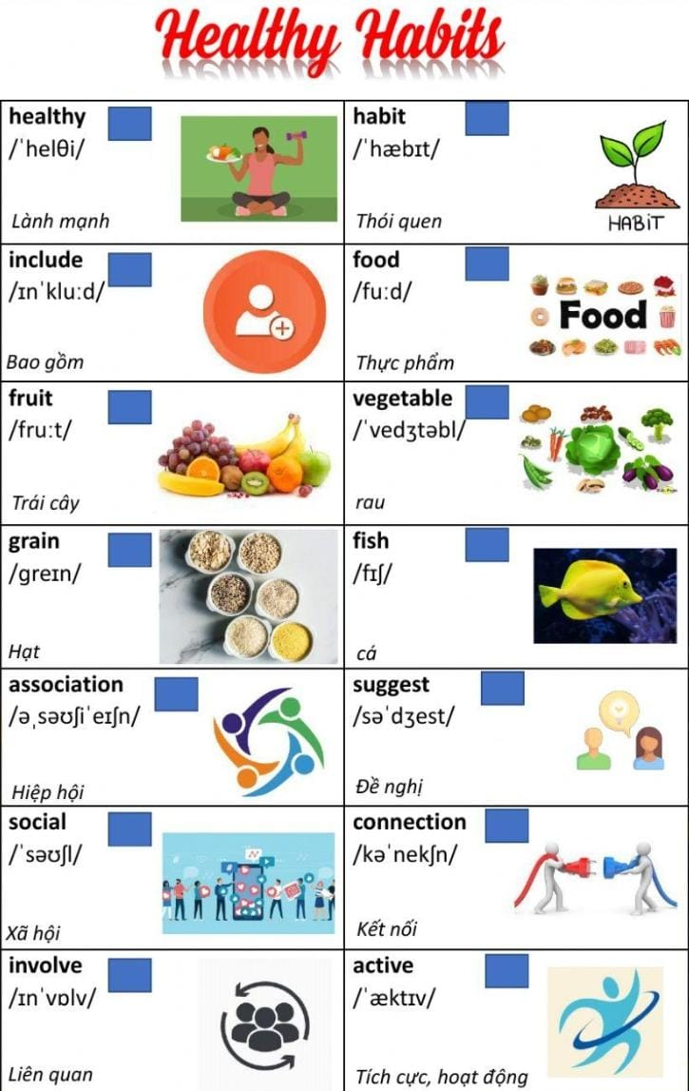

Activity 4
Match the word with the correct meaning.

in moderation (coll)  aerobic exercise (coll)  life expectancy (coll)  inadequate (adj)  overnight (adv)  unattainable (adj)  fruitless (adj) | not good enough a  not too much or too little  not productive/ no success  quickly  cannot be achieved  the number of years a person is expected to liveactivity that strengthens the heart and lungs

Activity 5

Fill in the blanks with the correct word.

1.If you burn more calories, you lose more....

2. Everybody must take... every day.

3.... that are strict can make you fatter.

4. You can eat as many.... and.... as you want.

5. Coffee is... for you.

6. You don't have to do.... If you don't eat too much.

7.... is good for you.

8....activity is very important for our health.

Words: physical, fruits, exercise, vegetables, fruits, diet, vitamins, weight, good.

Activity 6
Distribute healthy and unhealthy habits into the table.
Not Drinking Enough Water, Eating Late at Night, Cooking Everything in Olive Oil, Skipping Dessert, Not Changing or Sanitizing YourKitchen Sponge Frequently Enough, Drink More Water, Go for Evening Walks, Eat More Veggies.., Taking Daily Vitamins, Get a Good Night's Sleep.

Healthy habits: | Unhealthyhabits:

6. SPORT IN HUMAN LIFE

Activity 1
Text: Concept of sport
People all over the world are fond of sports and games.
Sport makes people healthy, keeps them fit, more organized and better disciplined.
It unites people of different classes and nationalities. Many people do sports on their personal initiative. They go in for skiing, skating, table tennis, swimming, volley-ball, football, body-building, etc.
All necessary facilities are provided for them: stadiums, sport grounds, swimming pools, skating rinks, skiing stations, football fields.
Sport is paid much attention to in our educational establishments. Gymnastics is a part of children's daily activities in the kindergartens. Physical culture is ч compulsory subject at schools and colleges.
Professional sport is also paid much attention to in our country. In city, where I live, there are different sporting societies, clubs and complexes.
Practically all kinds of sports are popular in our country, but football, gymnastics and tennis enjoy the greatest popularity. As for me, I go in for table tennis (ping-pong). It needs mobility, liveliness and much energy. It keeps a person in a good form. I have been playing tennis for five years, but the more I play, the more I like it. I get a real joy taking part in competitions or simply playing with my friends. Sometimes, I go to tennis courts.
Certainly, there's a great distance between my manner of playing and such favourites as Jim Courier, Stephan Edberg, Pete Sampras, Boris Becker, Per Korda, but I do my training with great pleasure and hope to play as well as our best players do.

Activity 2
Determine whether the sentences are true or false.

1) There are no conditions for athletes.
2) At the university, sport is called a physical education lesson.
3) The most popular sport in the world is football.
4) A person who plays sports gets fat.

Activity 3
Put the words in their place.
1) I love playing _______ since childhood.
2) Football was first registered in ________.
3) I first played football with my ________ when I was ______ years old.
4) My coach's name is ________, he has many __________ in football.
(England, Wayne, Achievements, Football, 7, Senior)

Activity 4


Text. Gennady Gennadievich Golovkin
Gennady Gennadievich Golovkin (GGG) - is a Kazakh professional boxer, competing in the middle and super middleweight divisions, World Champion in boxing among amateur athletes (2003), silver medalist of the Olympic Games held in Athens (2004). Two-time world champion according to IBF, WBA, IBO in professional boxing. The current IBO middleweight world champion by several definitions in world boxing. He was named Boxer of the Year by USA Today.
Honored Master of Sports of the Republic of Kazakhstan. 7-time champion of Kazakhstan, world champion among youth in 2000, champion of the first Spartakiad of Kazakhstan (2001), winner of the Cup among oil-producing countries in 2001, champion of the III East Asian Games (2001).
On February 26, 2024, he was elected head of the National Olympic Committee of the Republic of Kazakhstan.

Activity 5
Identification

Gennadin Golovkin Athletics
real Madrid A ride on the bicycle
Denis Ten Boxing
Olga Rypakova Ski race
Vladimir Smirnov Figure skating
Alexander Viyukurov Football

Activity 6
Sport equipment

Instructions:Post a photo of your favorite sports equipment below.

Activity 7
Find pictures of sports.

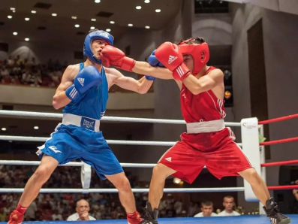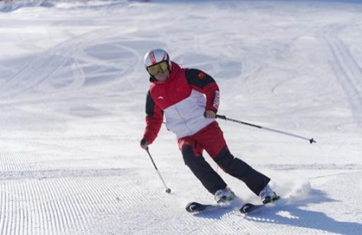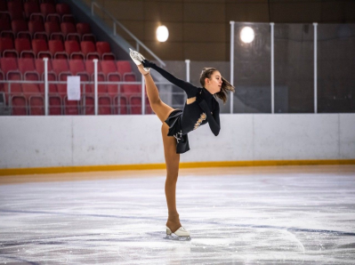

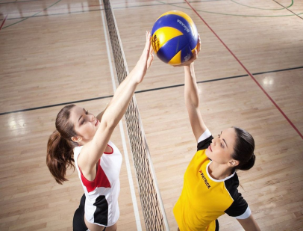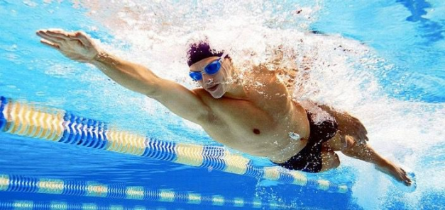

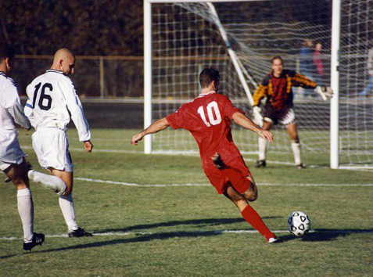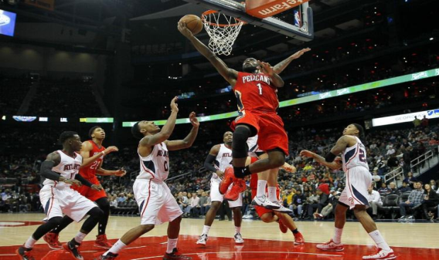

Activity 8
Description of the sport.

Instructions: Description of your favorite sport. Add information about the player's role and the rules of the game.

Activity 9
Interview with an athlete

Instructions: Interview your favorite athlete. Write answers to the following questions.

-Name of your favorite athlete?
-What sport does your athlete play?
-Why did you choose this sport?
-What advice would you give to young athletes?

Vocabulary:

спорт- sport
футбол-football
волейбол-volleyball
заниматься боксом-boxing
Баскетбол-Basketball
плавать-swim
горнолыжный спорт-skiing
Катание на коньках-Skating
настольный теннис-table tennis
бодибилдинг-body-building
стадион-stadium
Спортивные площадки-Sports grounds
Бассейн-pool
Скользкий-Slippery
Лыжные курорты-Ski resorts
Футбольное поле-Football field
гимнастика-gymnastics
профессиональный-professional
мяч-ball
Очки для плавания-Goggles
лыжи-skis
Скейтерская обувь-Skate shoes
теннисная команда-tennis team
Боксерские перчатки-Boxing gloves
упражнение-exercise
Расстояние-Distance

7. SPENDING FREE TIME
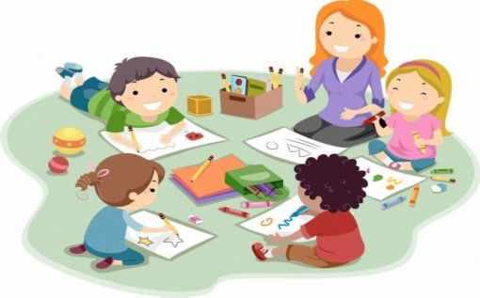
Activity 1
Text: Read and translate
Tips for spending free time
People don't know how to spend their free time when they are busy. There are those who make excuses for everything and waste it. Psychologists-scientists should come, people should monitor their free time and decide for themselves how to spend it. "What can you do?" to the question, psychologists advise: "Find a hobby that brings comfort to your soul." And how will that happen?
Handicraft
Knitting is an activity that relieves stress and frustration. You will feel comfortable and light while knitting. You can also do handicrafts such as embroidery, painting, ekibana, and bead weaving. If you say, "I can't do any of this," try to learn by browsing social media or an educational book.
Flowering
Many people spend their free time in the garden. Of course, if you live in a country house, why not plant flowers in the garden, make it beautiful and grow?! And you can't plant too many flowers in a multi-story house. However, you can make a small garden on the balcony. Sow the seeds of your favorite houseplants in small flower pots and start caring for them.
Pets
Feed the desired pets in the aquarium, such as fish, cats, dogs, and turtles. Take care of them and spend your free time raising them.
Blogging
Sign up for information and educational portals on the Internet and blog. Write down interesting events that happened to you, your thoughts, and pay attention to the opinions of others. Share your thoughts with others in forums on various topics.
Vocabulary:
Tips for spending free time
Free time-свободное время
Handicraft-ремесло
Knitting-вязание
Book-книга
Social media-социальные медиа
Flowering-цветение
Small flower-маленький цветок
Pets-домашние питомцы
Aquarium-аквариум
Fish-рыба
Cats-кошки
Dogs-собаки
Turtles-черепахи
Blogging-веление блога
Information-информация
Activity 2
Answer the questions below
1)What do you do in your free time?
2)What is your hobby?
3)Do you love blogging?
4)Do you like pets?
Activity 3
Answer the test questions
1) Who should be consulted for effective use of free time?
a) From parents
b) From the teacher
c) From a psychologist
2) A hobby that develops your imagination?
a) Keeping domestic animals
b) Dancing
c) Drawing
3) What hobby for physical development?
a) Coloner
b) Football
Activity 4
Text:Read and translate
My hobby
I like to devote my free time to my favorite hobby. Each person has a favorite activity according to his own taste and inner world. Some dance and find their place, others sing, others play sports.
My favorite hobby is painting. I have been drawing since I was three years old. I am going to an additional drawing class at a special art school. It seems that there is a secret in drawing, because in the process of drawing you give freedom to your imagination and express what is in your mind through a picture. In the future, I dream of becoming a world-famous artist.
I devote all my free time to painting, I try to improve my talent, I admire the works of world-famous artists.
I will definitely go to the exhibition of the art gallery in the city, because the works of famous brush masters will certainly not leave anyone indifferent, and through this you can get spiritual food and drink. Also, I try to learn things I didn't know before by participating in master classes that are very popular nowadays.
I have set myself a goal and dream of becoming a world famous artist in the future.
Vocabulary:
My hobby
Favorite hobby-любимое хобби
Dance- танец
Place- место
Sing- петь
Play sports- заниматься спортом
Painting-рисование
Famous artist-известный художник
Gallery-галерея
Activity 5
Fill the gaps with the correct word from the box.
5 items remaining
*Time
*Painting
*Myself
*Flowers
*Blog
1. My favorite hobby is____
2. I have set __ a goal and dream of becoming a world famous artist in the future.
3. I like to devote my free __ to my favorite hobby.
4. And you can't plant too many ___in a multi-story house.
5. Sign up for information and educational portals on the Internet and___
5 items remaining
Sign up for _______ and educational ______ on the Internet and blog. Write down interesting events that _______ to you, your thoughts, and pay attention to the _____ of others. Share your thoughts with others in forums on various _______.

(information,happened,opinions,portals,topics)

Activity 6
Match the term leisure and its correct definition.
____Dance
____Fish
____Painting
____Pets
____Dogs
____Handicraft
____Blogging
____Flowering
a)Knitting is an activity that relieves stress and frustration.
b)Young women spend their free time in the garden.
c)They like to be cared for by people.
d)Share your thoughts with others in forums on various topics.
e)You do a lot of activities.
f)Rest your brain and think.
g)It lives in water.
h)He is a close friend of man
Activity 7
Text:Read and traslate
Leisure and hobbies
Leisure and hobbies. A hobby is doing something you like in your free time. Kazakhs have a proverb from ancient times: The wasted time is the wasted life. Everyone uses their free time differently. Some people spend their free time reading biographies of famous people in books.
For example: My grandmother. My grandmother lives in the city of Almaty in the south of Kazakhstan. My grandmother always memorized proverbs from those books. After memorizing, he always tells me those proverbs. He understands the value of time. They say this to everyone in the house: "Don't sit idle, do something, for example, read a book." He understands the value of time and does not waste it. And some people waste their time without realizing it, and so their lives are wasted.
And how do I spend my free time? I have a hobby. My hobby is football. I spend my free time on the football field. I play football with my friends. In addition, I go to football training on Saturdays and Sundays. There I will develop my football skills. Because I dream of becoming a football player since my childhood. That's how I spend my free time. Secondly, it is very useful for me. Because football is a kind of sport. It has many reasons for the physical development of my body. A person engaged in sports does not get sick a lot and has good health.
I think everyone should do something useful in their spare time.
Vocabulary:
Leisure and hobbies
Leisure-досуг
Hobby-хобби
Football-футбол
Childhood-детство
Sport-спорт
Health-здоровье
Activity 8
Write your hobby
Instructions:
I like to devote my free time to my favorite hobby. Each person has a favorite activity according to his own taste and inner world. Some dance and find their place, others sing, others play sports.
My favorite hobby is painting.
Activity 9
Answer the questions below
1)What do you do in your free time?
2)What is your hobby?
3)Do you love blogging?
4)Do you like pets?
Activity 10
Text:Read and traslate
Tips for choosing a hobby
In my opinion, the best rest is a change of activity. Therefore, in your free time, I advise you not to be lazy on the couch watching TV, but to come up with an interesting hobby. Do something that inspires, captivates, and brings joy. It can be any activity that you like.
You can embroider, draw, sculpt - creative activity helps you “switch” and also brings satisfaction from the results of your work.
Don’t forget to be active, be sure to take a walk, play sports outdoors or in the gym. Moderate physical activity significantly helps reduce stress levels, increases endurance, and distracts from negative thoughts and problems.
And interesting ideas and solutions often come to a “fresh” mind.
Be sure to educate yourself. Read books, watch lectures or listen to podcasts. For example, it is convenient to listen to audiobooks on the way to work or while walking.
Learn languages. Try to master at least standard phrases, for example, in English.
Try to observe one of the important conditions for proper rest - not to be distracted by phones and gadgets, not to look at social networks, but to focus on what you are doing here and now. Try to completely immerse yourself in the activity and put other everyday problems aside.
If you have a lot of free time and feel the need to help people, try volunteering. This is an interesting, albeit difficult activity, it involves new acquaintances and emotions, as well as real help to those who need it. We need your attention and support.
However, balance your strengths, do not try to cover everything at once. Remember that any activity should bring satisfaction and not become torture.
Vocabulary:
Tips for choosing a hobby
Watching TV-Смотреть телевизор
Sculpt-Лепить
Learn language-Изучай язык
Phrases-Фразы
Social networking-Социальная сеть
Support-Поддерживать
Activity 11
Determine whether the text is correct or incorrect.(T and F)
1. Waste of time is waste of life. Everyone uses their free time differently, this proverb was mentioned in the first text.
2. Animals do not like to be spanked
3. Knitting is not an activity that relieves stress and frustration.
4. Soccer was mentioned in 2 texts
5. A little boy in 3 texts because I have dreamed of becoming a football player since I was a little boy.
6. Feed desired pets like fish, cats, dogs and turtles in the aquarium
Activity 12
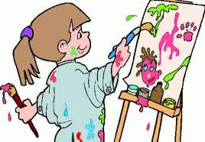
Make sentences looking at the pictures

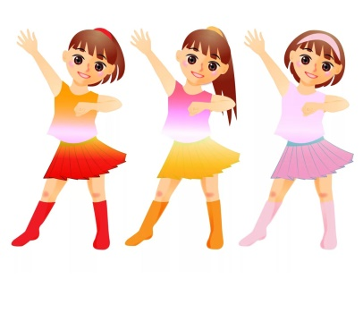

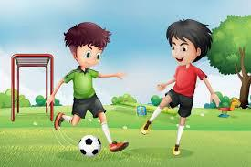


Activity 13
Have a dialogue with the person next to you about your hobby.

8. WORLD MAP
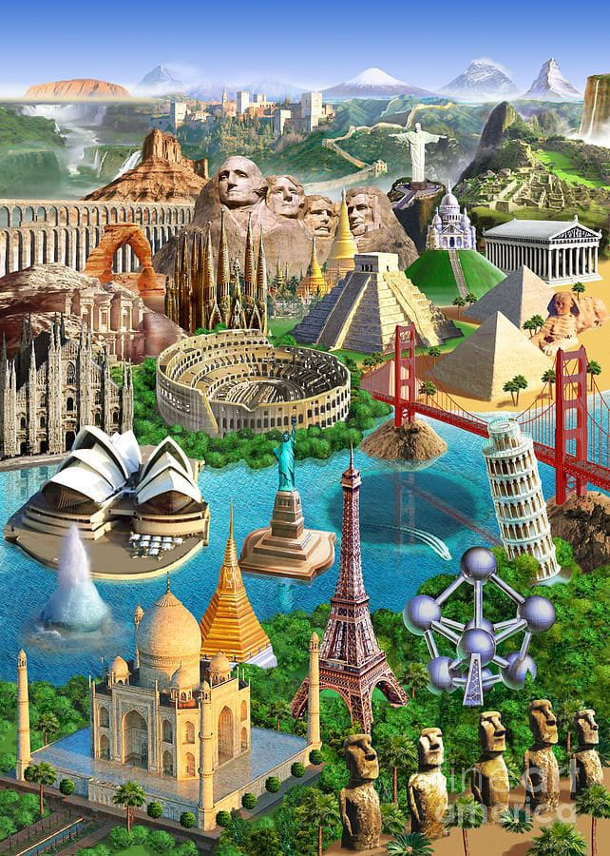
Activity 1
Text: Read and translate
World map
We all came across a map of the world in geography lessons. She gives us a general idea of the world structure. But let's not forget that the map is just a flat and conditional model of a round ball.
The planet we live on is known as Earth. The waters of the World Ocean wash its main territory. The parts of the land marked on the map in the form of large islands are called continents. They are presented as: Eurasia (united Europe with Asia), Africa, North and South America, (represent part of the world – America), Australia, Antarctica.
There are four huge oceans on the planet. Pacific Ocean ranks first in its huge size. This is followed by the Atlantic Ocean, which is only slightly inferior to the Pacific Ocean. The third place is occupied by the Indian, and the smallest is the Arctic Ocean.
The map shows the equator – a conditional line that divides the globe into two hemispheres: the Northern Hemisphere and the Southern Hemisphere. The world map also displays mountain, forest and river systems, plains, lakes, seas, waterfalls, swamps. Such a card is called a physical card. There is also a political map of the world, which represents the location of countries and states with their borders. Let's focus on Canada, which is the country's second largest territory.
Canada is a vast country, bigger than the United States, bigger than the continent of Australia. It is in fact one of the world's largest countries. Its area is about 10 mln sq km.
As Canada extends for thousands of miles from the Arctic Ocean to the United States and from the Atlantic Ocean to the Pacific Ocean, all kinds of weather conditions and scenery are to be found there. The population of Canada is 29 mln people. The capital is Ottawa; the main cities are Toronto, Montreal and Vancouver. The word Canada comes from one of the Red Indian languages – «Kannata», meaning «a number of huts». Canada is often called the «Land of the Maple Leaf». The maple leaf is the national emblem of Canada. The story of Canada goes back over 400 years. The French were the first settlers to this country. In 1759 Canada became a part of the British Empire. In 1931 became independent from Britain. Today Canada is an independent federative state, consisting of 10 provinces and 2 territories. It is a member of the Commonwealth, headed by the Queen of Great Britain. The two official languages are English and French. But many other languages are spoken: Italian, Chinese, German, Polish and Greek. Canada is a country with very high standards of living. This country is particularly advanced in the areas of health, education, social protection and human rights

Vocabulary:
World map
- Map - карта
- Latitude – Широта
- Equator – Экватор
- Planet – Планета
- Ocean – Океан
- Territories – Территории
- Natural boundaries – Природные границы
- Governments – Правительства
- Countries – Страны
- States – Штаты
- Provinces – Провинции
- Rivers – Реки
- Regions- Регионы

Activity 2: Mark the sentences as True or False.

- The planet we live on is called earth.
- There are 5 big oceans on earth.
- Parts of the land marked as large islands on the map are called continents.
- The map shows the equator-the conventional line dividing the globe into two hemispheres.
- Pacific Ocean ranks last in terms of its size.
- Canada is one of the largest countries in the world.

Activity 3: Answer as many of questions 1-8 as you can in two minutes. How many did you get ?

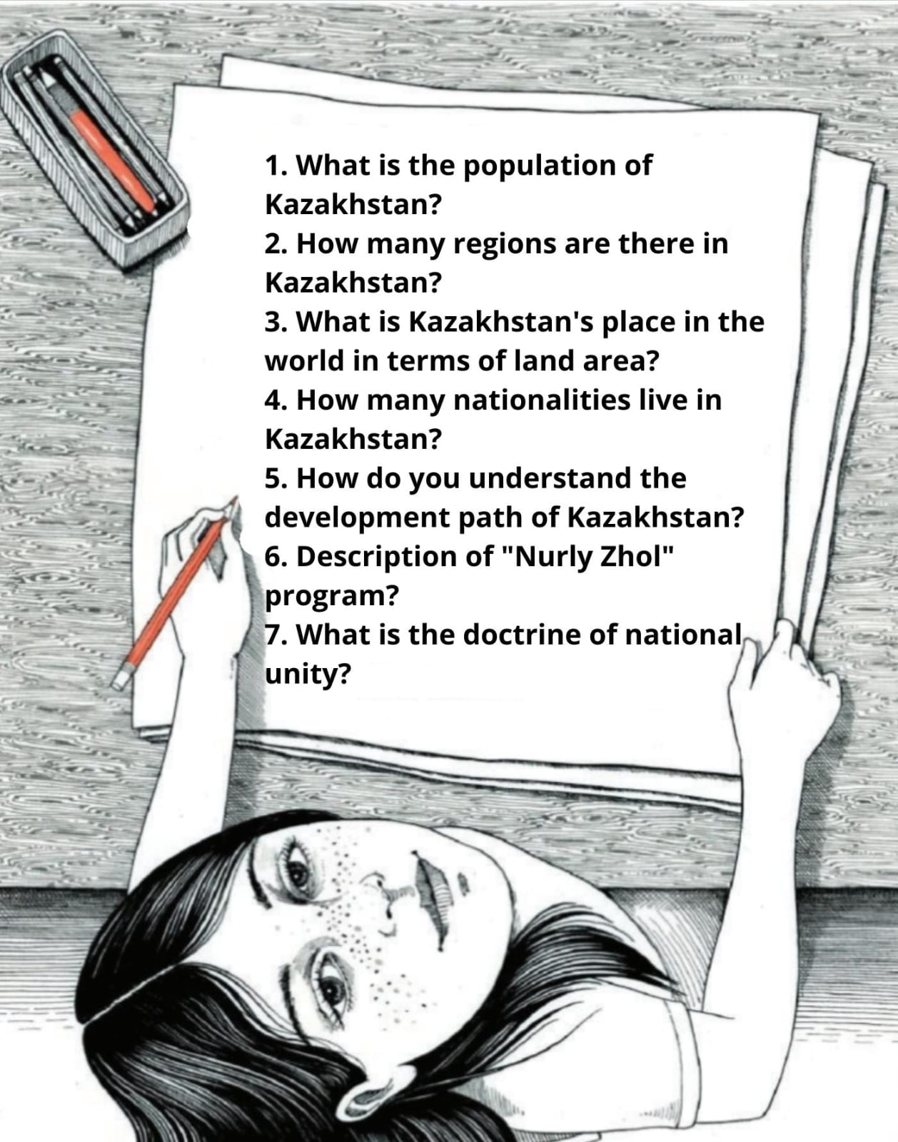

Activity 4: Discuss with your partner. Which country have you been to and which country do you want to travel to? Lost your documents while traveling, what would you do?

Activity 5: Match the words in the list to definitions A-F.

Map river mainland lake the sea

- A set of heterotectic bodies with a complex composition formed as a result of physical-chemical and gravitational classification of its outer layers during the geological development of the Earth
- A reduced image of the surface of the Earth, the starry sky or its parts using cartographic projections, created using conventional symbols
- Is a small part of the ocean that is located close to the land or is separated from other parts of it by land shores, peninsulas or islands.
- Sewage flowing in its natural channel or a natural course of flowing fresh water.
- Independent depressions filled with water in land areas not directly connected to the sea.

Activity 6: Where do you live? Point on the map

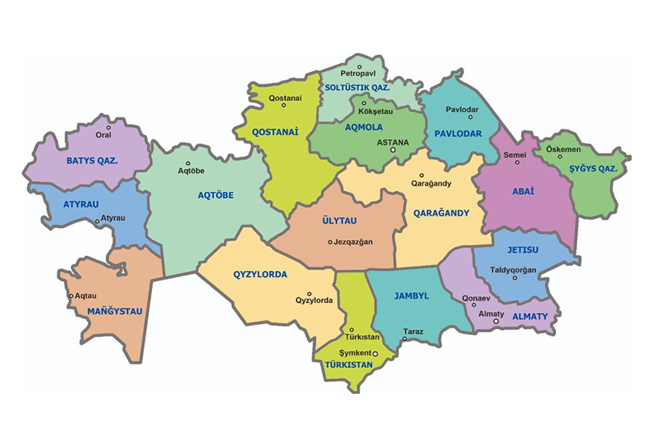

Activity 7. Read the text. Fill in the blanks and translate the words.

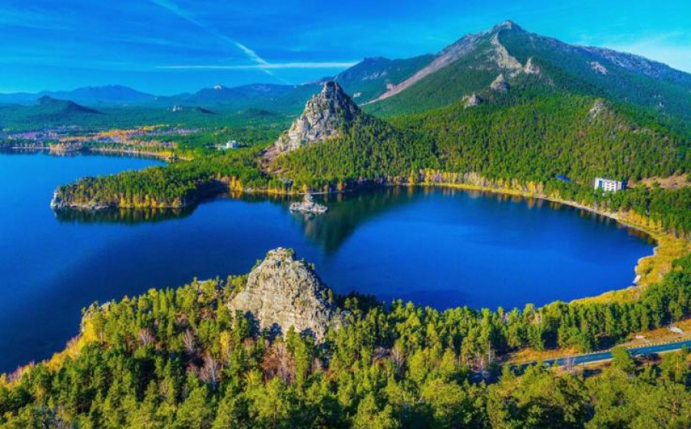

Burabay is an amazing place in Kazakhstan that attracts ____ with its beauty and unique nature. This is a national park located in the southwest of ______ and is surrounded by pine forests, sand dunes and crystal clear lakes. Burabay is also known for its mountains,______ and _____ that mesmerize everyone who visits the place.
One of the most ______ in Burabay is Borovoe, where you can see picturesque rocks, caves, waterfalls and lakes. Tourists can indulge in hiking, horseback riding, wakeboarding, paragliding and other activities while enjoying the beauty of nature and fresh air.
In addition to ______, in Burabay you can visit various cultural and historical places, such as museums, madrassas and mausoleums. Here you can also try national Kazakh
tourists, Laki Balkhash,picturesque canyons, breathtaking views, famous places,natural attractions, adventure filled

Activity 8.What are the capital cities of these countries?

A) Korea
B) Argentina
C) Poland
D) Canada
E) the USA
F) Japan

Activity 9. Read the text, translate it and ask 3 questions that reveal the topic.

Why Borovoe is called Kazakh Switzerland, the magical nature of Burabay
Burabay is located on the territory of a national reserve. There is a pine forest with the cleanest air, beautiful mountains and many lakes. Due to its unique nature, Borovoe is often compared to Switzerland. This picturesque corner is located among the endless steppe.
Forested mountains occupy a small part. If you climb to the top of one of the hills, you can see an unsightly picture of the steppe. This allows you to appreciate the contrast with the picturesque nature of the national park.
For those who come to Kazakh Switzerland (Borovoye), it almost immediately becomes clear why Kaz is called that. Switzerland. Mountain peaks, meadows and fields create unique landscapes. The lakes located on the territory of the reserve deserve special attention. Borovoe is considered the most famous. However, there are many other lakes in these places that deserve the attention of tourists.
Kokshetau is considered the highest mountain in Borovoye. The peak has another name: “Sinyukha”. Not far from it is Mount Burabay, almost 700 m high. From its highest point there is a magnificent panorama of the local nature. Rest in Borovoye.
Tourists come to Borovoe all year round. In winter, Burabay turns into a comfortable ski resort, which is almost equal in level to European ones. Trails of varying difficulty levels are equipped for tourists.
In summer, travelers who prefer beach holidays come to these places. The water in the lakes warms up already at the end of May. The beach season lasts until the end of summer, and sometimes extends into September.
In the off-season, people come to Borovoe for walks in the surrounding area and excursions to natural attractions. It is not for nothing that the resort is compared to Switzerland, thanks to its beautiful nature and unique climate. There are many sanatoriums offering medical treatments here. The healing climate has a positive effect on the well-being of vacationers. A trip to Borovoe always leaves only positive emotions.

Vocabulary:

- Small-маленький
- Mountain-гора
- Snow-снег
- Ski-лыжи
- Nature-природа
- Culture-культура
- Ancient-древний
- Purity-чистота
- Excellent-отлично
- Jewelry-ювелирение изделения
- Spiritual-духовно
- Amazing-удивительный
- Museum-музей
- tradition-традиция
- Lake-озера
- opportunity-возможность
- Winter -зима
- reliable-надежный
- Comfort- комфорт
- quality- качество
- Place-место
- unique-уникальный
- high-высокий
- History-история

Activity 10.Look at the flags, find out what country it is, and talk about those countries.

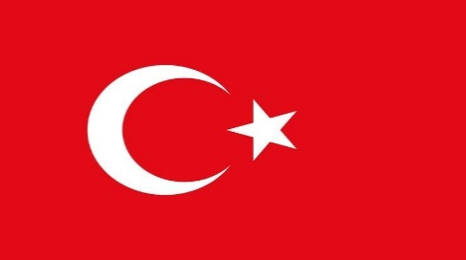
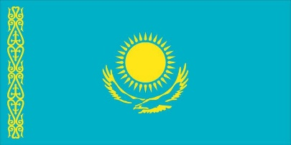


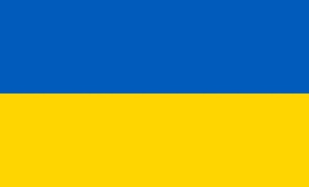
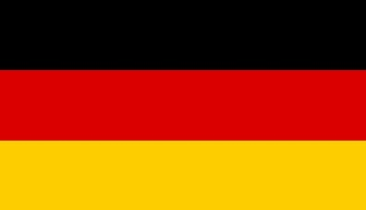
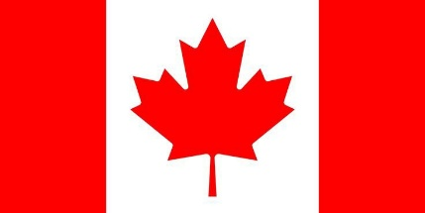
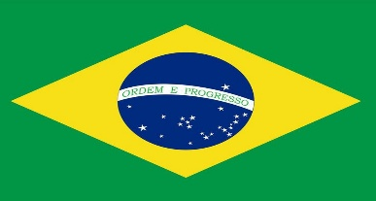


- GEOGRAPHICAL LOCATION AND BOUNDARIES

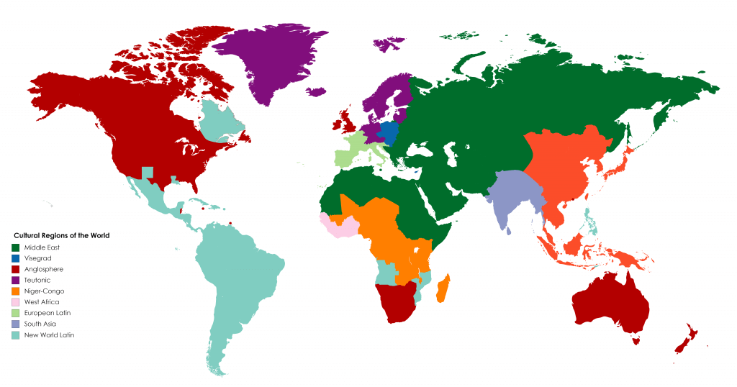
Activity 1
Text: Read and translate
Geographical location

Geographical location refers to the position of a place on Earth's surface, determined by its latitude and longitude coordinates. These coordinates provide a precise way to identify the location of any point on the planet. Latitude lines run horizontally around the Earth, measuring the distance north or south of the Equator, while longitude lines run vertically from pole to pole, measuring the distance east or west of the Prime Meridian.
Boundaries, on the other hand, define the limits of areas or territories. They can be political or natural in nature. Political boundaries are created by governments to separate one political entity from another, such as countries, states, or provinces. These boundaries are often marked by imaginary lines or physical markers, and they can change over time due to political agreements or disputes.
Natural boundaries, on the other hand, are formed by geographical features such as rivers, mountains, and oceans. These features serve as natural dividing lines between regions or countries. For example, the Mississippi River forms a natural boundary between several states in the United States, while the Andes Mountains separate Chile from its neighboring countries in South America.
The establishment and maintenance of boundaries have significant geopolitical implications. Borders can shape the identity and sovereignty of nations, influence trade and migration patterns, and even lead to conflicts or disputes between neighboring countries. Throughout history, wars have been fought and treaties signed over territorial claims and boundary disputes.
In modern times, advances in technology, such as satellite imagery and Geographic Information Systems (GIS), have made it easier to map and demarcate boundaries with precision. However, challenges remain, particularly in regions with complex or contentious territorial issues.
In conclusion, geographical location and boundaries are fundamental concepts in geography and geopolitics. They define where places are located on Earth's surface and determine the extent of political and territorial jurisdictions. Understanding these concepts is essential for analyzing the dynamics of our world and the relationships between nations and regions.

Vocabulary:
Geographical location
- Position – Положение
- Surface – Поверхность
- Latitude – Широта
- Equator – Экватор
- Limits – Пределы
- Avalanche- Лавина
- The arctic- Арктика
- Bay- бухта,залив
- Breeze-легкий ветерок
- Bog- трясина
- Coast- побережье
- Dam- Дамба
- The Southern Hemisphere- Южное полушарие
- The Eastern Hemisphere- Восточное полушарие
- The Western Hemisphere- Западное полушарие

Boundaries
- Areas – Области
- Territories – Территории
- Natural boundaries – Природные границы
- Governments – Правительства
- Countries – Страны
- States – Штаты
- Provinces – Провинции
- Rivers – Реки
- Regions- Регионы

Activity 2: Mark the sentences as True or False.

1) A meridian is a line across the Earth that measures the distance north or south of the equator
2) Geographical location refers to the position of a place on Earth's surface, determined by its latitude and longitude coordinates.
3) Political boundaries are created by governments to separate one political entity from another, such as countries, states, or provinces.
4) Natural boundaries Geographical location means the location of the land on the earth's surface determined by latitude and longitude coordinates
5)The Mississippi River serves as an American border between several states of the United States
6) Lines of latitude run vertically from pole to pole and measure the distance east or west from the Prime Meridian.

Activity 3: Boundary Debate:
Select a controversial boundary, such as a disputed territory or a proposed border change, and host a debate. Assign participants different roles representing various stakeholders involved in the boundary issue. Encourage critical thinking and discussion about the geographical, political, and social implications of the boundary.

Activity 4: answer the questions

- Find all countries starting with the letter "A" and mark them on the map.
- Explore the Amazon River and find out how many countries it passes through.
- What is the main mountain in Africa?
- Traveling along the border between the USA and Mexico will help you understand its complexity.
- Locate the geographical position of Everest and describe it.

Activity 5: Discuss the questions with a partner

- How do political boundaries impact the lives of people living near them?
- What factors contribute to the formation and changes of geographical boundaries over time?
- How do natural boundaries, such as rivers and mountains, influence human settlements and interactions?
- What are some examples of disputed boundaries around the world, and what are the implications of these disputes?
- How do modern technologies, such as GPS and satellite imagery, aid in defining and monitoring geographical boundaries?
- In what ways do cultural differences influence perceptions of geographical boundaries?
- How do climate and environmental factors affect the establishment and maintenance of borders?
- How can the concept of borders and boundaries be applied beyond physical geography, such as in social, economic, and digital realms?
- What are the challenges and benefits of creating transnational or supranational boundaries, such as those in the European Union or international waters?
10.How do geopolitical shifts and power dynamics influence the drawing and recognition of national borders?

Activity 6:
Text:Read and translate

Introducing the 10 countries with the largest area in the world! The list includes both the most ancient civilizations and states whose history does not exceed 200 years. A variety of peoples coexist across vast territories and combine contrasting traditions and customs. Planning to cross them from edge to edge? Then pack your suitcase wisely: you may have to change your fur coat to shorts, because the snowdrifts outside the train window can turn into sunny beaches in a few days.
Russia is the biggest country in the world. It stretches from the Baltic Sea in the west to the Pacific Ocean in the east. Russia has a huge amount of natural treasures.After the collapse of the British Empire, Great Britain lost dozens of positions in the ranking. But its numerous colonies are firmly established on the top lines, for example, Canada. The United States of America occupies one of the leading places in the ranking of countries with the largest number of natural sites. Until recently, China was considered the most populous country, but this year India overtook it. Brazil occupies almost half of South America. It is the only country in the world that occupies an entire continent. It also enjoyed the status of a British colony for a long time.India recently overtook China as the world's most populous country. Together with Egypt and China, it is one of the most ancient civilizations.
From the 6th to the 13th centuries, the territory of Kazakhstan was part of one or another kaganate (a kaganate is a form of a medieval state whose people led a nomadic lifestyle). After the conquests of Genghis Khan, these regions became part of the Mongol Empire

Vocabulary:

- Territory- Территория
- Ocean- Океан
- Rating- Рейтинг
- Number of people- Число людей
- Land area-Площадь земельного участка
- State-состояние
- Ancient state-Древнее государство
- Sea-Море
- Atmosphere- Атмосфера
- Climate -Климат
- Environment -Окружающая среда
- Hemisphere -Полушарие
- Landscape- Пейзаж
- Latitude -Широта
- Longitude -Долгота
- Map- Карта
- Pollution -Загрязнение
- Population -Население
- Temperature -Температура
- World -Мир
- North -Север
- South - Юг
- West -Запад
- East -Восток

Activity 8: Mark the sentences as True or False
1)Only the oldest states are included in the list of the largest states in the world.
2) Russia is the largest country in the world.
3) India is the most populous country
4)Russia stretches to the Pacific Ocean in the west.
5) America is the only country in the world that occupies an entire continent.

1) false
2) true
3) true
4) false
5) true

Activity 9: Match the words in the list 1-8

Globe Wstern Hemisphere Meridian Landscape Tropics Hemisphere on water World ocean Equator

- A three-dimensional model of the Earth or another planet, as well as a model of the celestial sphere
- hemisphere of the Earth located west of the Greenwich meridian and east of the 180th meridian.
- A specific territory, homogeneous in its origin, history of development and indivisible according to zonal and azonal characteristics.
- conventional line of section of the earth's surface by a plane passing through the center of the Earth, perpendicular to its axis of rotation
- climatic zones of the Earth in which the Sun is at its zenith at least once a year
- represents the hemisphere of the Earth, with the center located at the coordinates
- half section line surface of the globe by a plane drawn through any point on the earth's surface and the axis of rotation of the earth
- the main part of the hydrosphere, a continuous but not continuous water shell of the Earth

Activity 10: Match the states by land area.

- Russia
- Canada
- China
- USA
- Brazil
- Australia
- India
- Argentina
- Kazakhstan
- Algeria

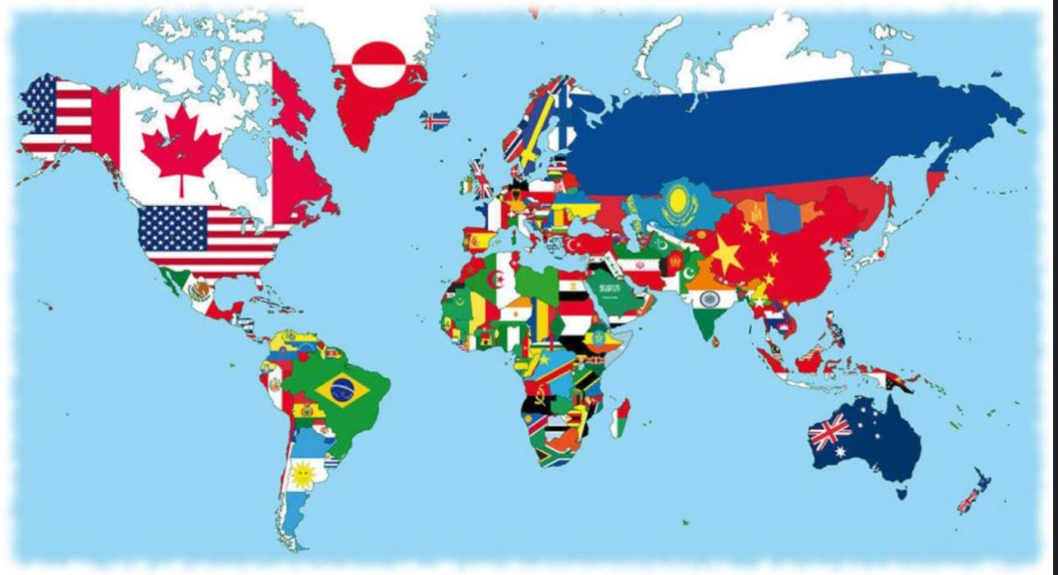

Activity 11: Discuss the questions with a partner
- What distinguishes Russia's geographical span from the Baltic Sea to the Pacific Ocean?
- How did the collapse of the British Empire impact Great Britain's position in the ranking of countries by size?
- Which country occupies the largest portion of South America, and what unique distinction does it hold?
- What significant demographic shift occurred recently between India and China?
- Which countries are regarded as some of the most ancient civilizations, alongside China and Egypt?
- What historical influences have shaped Kazakhstan's territory, particularly during the medieval period?
- How does the United States rank in terms of natural sites among countries worldwide?
- What unique historical ties does Brazil have as a former British colony?
- Which country currently holds the title of the world's most populous, surpassing China?
- How did India's recent population milestone impact its global standing?

10 ATTRACTIONS OF THE CITY.
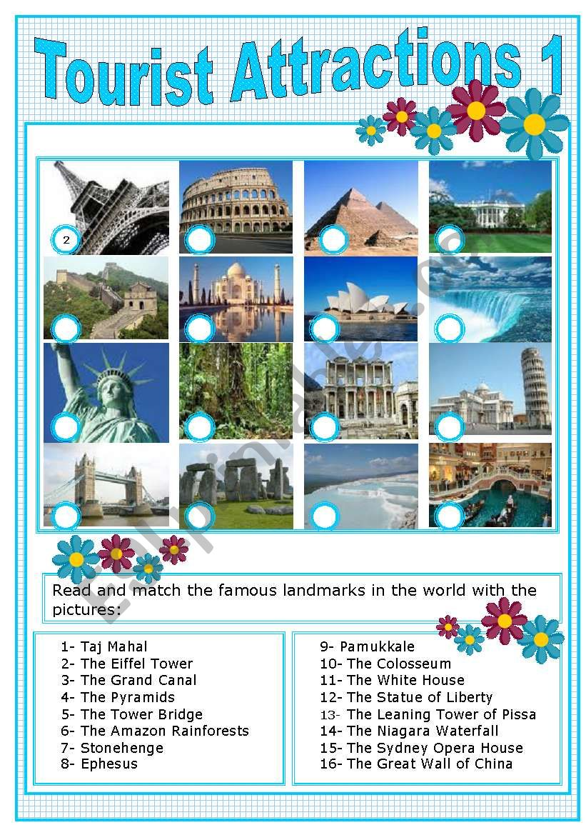
Welcome to our city! Whether you're a visitor or a local resident, there are plenty of attractions to explore. From historical landmarks to cultural hotspots, our city offers something for everyone. Let's dive into some vocabulary exercises related to city attractions.
Activity 1: Match the Words
Match the words on the left with their definitions on the right.
1. Landmark a. A large, public outdoor area for relaxation and recreation.
2. Monument b. A famous or historically significant building or structure.
3. Museum c. A place of interest or beauty that is preserved for public enjoyment.
4. Park d. A structure built to honor a person, event, or idea.
5. Sculpture e. A place where objects of historical, artistic, or scientific significance are displayed.

Activity 2: Fill in the Blanks
Fill in the blanks with the appropriate words from the list below.
List of Words:
1. Fountain
2. Tourist
3. Gallery
4. Theater
5. Observation
6. Aquarium
Exercise:
1. The _____________ in the city center is a popular spot for photos.
2. Many _____________ enjoy visiting our historical sites and museums.
3. The art _____________ showcases works from local and international artists.
4. Catch a play or musical at the local _____________.
5. From the _____________ deck, you can enjoy breathtaking views of the city skyline.
6. Visit the _____________ to see a diverse range of marine life.

Activity 3: Describe the Attraction
Choose one of the attractions from the list below and write a brief description of it.
1. Botanical Garden
2. Historic Cathedral
3. Street Market
4. Science Center
Description Example:
Historic Cathedral:
The historic cathedral, nestled in the heart of the city, is a magnificent example of Gothic architecture. Its towering spires and intricate stone carvings draw visitors from near and far. Step inside to admire the stained glass windows that filter sunlight into a kaleidoscope of colors. As you explore the cathedral's interior, you'll feel a sense of awe at the centuries of history contained within its walls. Don't forget to climb the bell tower for panoramic views of the city below.
Absolutely, let's delve into some vocabulary exercises centered around attractions of the city:

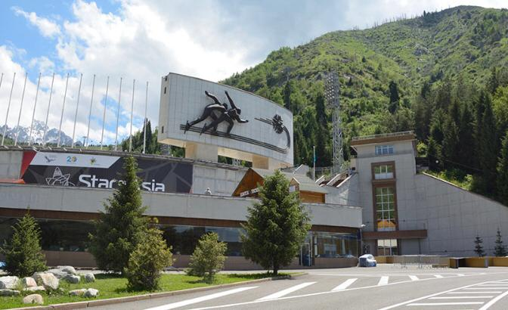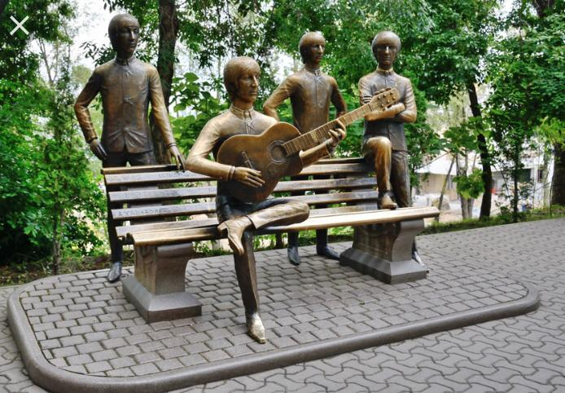
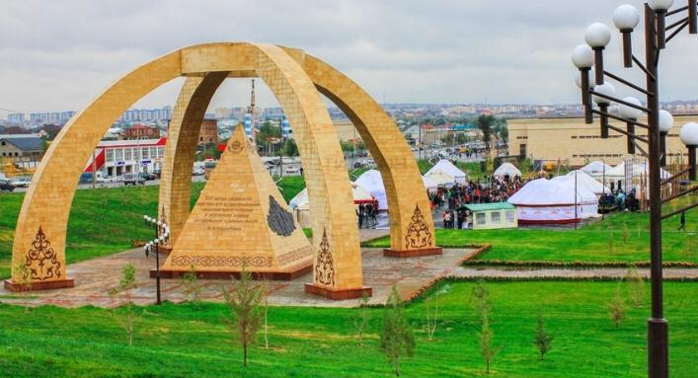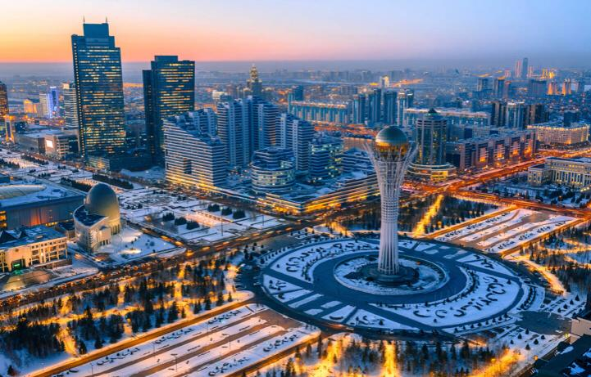

Activity 4: Vocabulary Matching
Objective: Introduce and reinforce vocabulary related to city attractions in Kazakhstan.
- Instructions: Match the words on the left with their definitions on the right.
Vocabulary Words | Definitions
1. Mosque | A large public park or garden
2. Bazaar | A traditional market selling goods
3. Monument | A large structure built to commemorate an event or person
4. Park | A place of worship for Muslims
5. Square | An open area in the city often used for public gatherings
- Example:
  - Mosque = 4
Words to use: Mosque, Bazaar, Monument, Park, Square

Activity 5: Reading Comprehension
Objective: Develop reading skills while learning about city attractions in Kazakhstan.
- Instructions: Read the following passage about city attractions in Kazakhstan and answer the questions below.
Kazakhstan is a country with rich cultural heritage and beautiful cities. Nur-Sultan, the current capital, boasts modern attractions like the Bayterek Tower, a monument symbolizing the city's aspirations. Nur-Sultan showcases modern architecture and attractions. The Baiterek Tower, symbolizing a Kazakh folk tale, offers an observation deck with stunning city views. The National Museum of Kazakhstan, located in Nur-Sultan, provides insights into the country's history and culture.
Kazakhstan is a diverse country with fascinating cities offering unique attractions. Almaty, the largest city, is known for its scenic beauty and cultural sites. One must-visit attraction is the Zenkov Cathedral, a beautiful wooden church located in Panfilov Park. Another highlight is Kok-Tobe Hill, where visitors can enjoy panoramic views of the city and visit the colorful "Love Lock" wall. Don't miss the bustling Zelyony Bazaar in Almaty, where you can experience local foods and crafts.

Questions:
  - What can you see in Panfilov Park and what is it known for?
  - What is the Bayterek Tower, what does in symbolize?
  - Where can you experience local foods and crafts in Almaty?
- Where can visitors go to enjoy panoramic views of Almaty?

11. THE CUSTOMS OF THE REPUBLIC OF KAZAKHSTAN AND THE COUNTRY WHERE THE LANGUAGE IS TAUGHT

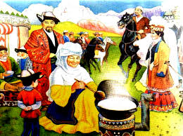

Activity 1. Read the text and translate

Hospitability in Kazakh society is a primary duty and entails reception of guests with open heart and welcoming embrace. A guest is the most important and desirable person at a house. It is customary to provide a guest with the most delicious food and do everything to make a guest feel in safety and comfort.
The Kazakh people sacredly honor the customs and traditions inherited from their ancestors. For the sake of objectivity, it should be said that over the years of existence, the Kazakh nation has accumulated so much baggage in this area that it is practically impossible to tell about all the traditions and customs inherent in the descendants of the sultans Zhanibek and Kerey (the founders of the Kazakh Khanate) in one article.
The main tradition of the Kazakhs, which eventually transformed into a feature of the national character, is hospitality. There is an unofficial law in Kazakh society, voiced in ancient times. It says - meet the guest as a messenger of God.
Hospitality is considered a sacred duty in Kazakh society. At all times, the steppe people did everything possible to please the guest. Therefore, every traveler, going on the road, knew that he would be warmly welcomed in any corner of the Kazakh land.
Respect for elders is another positive feature of the Kazakh people. Traditionally, a child from the "young nails" is taught restraint and integrity when dealing with adults, wise people with life experience.
However, the above-mentioned national peculiarities, the basis for the emergence of which were generalized norms and principles of public relations (traditions), fortunately, are inherent not only to representatives of the Kazakh people. Therefore, next, we offer you a list of the main customs that have become widespread in Kazakh society.
Activity 2:
  - TRADITIONS AND CUSTOMS RELATED TO THE PRESENTATION OF GIFTS
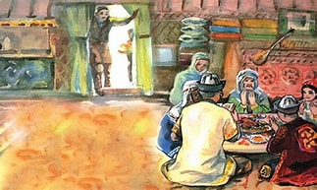
Suyinshi is a custom according to which a traveler who brings good news to the house receives a valuable gift from the owners in gratitude.
"At mingizip shapan zhabu" is a high honor. According to tradition, dear guest, they can be akyn, batyr or just a very respected person who visited the village, in recognition of his merits, receives a horse and an expensive chapan (camel wool robe with a calico lining) as a gift from the locals.
Bes zhaksy is a gift consisting of five valuable things at the same time. It includes: a camel ("kara nar"), a fleet-footed steed ("zhuirik at"), an expensive carpet ("kaly keel"), a diamond saber ("almas kylysh"), as well as a sable fur coat ("bulgyn ishik"). Bes zhaks, as well as "At mingizip shapan zhabu", are awarded to the most respected people in the Kazakh society.
Baigazy is a tradition that provides for the possibility of receiving a gift by a person who has purchased a new thing.

Activity 3
2. TRADITIONS AND CUSTOMS RELATED TO MUTUAL ASSISTANCE

Asar - a family that has a need to perform some successful, sometimes hard work, has the right to call relatives, friends and neighbors to help. At the end of the case, a rich table is laid for the assistants.
Zhylu is a tradition associated with providing material, moral and financial assistance to people affected by natural disasters (fires, floods, etc.). All sympathizers, not just relatives, have the right to help the victims. Donations may include livestock, building materials, clothing, money.
Bel koterer is a tradition to treat elderly people. For the elderly, delicious, and most importantly – soft dishes such as kazy, zhent, koumiss, cottage cheese, etc. are prepared. As a rule, this duty is imposed on children or close relatives, less often neighbors. The Belkoterer tradition is an example of caring for the elderly.

Activity 4. TRADITIONS AND CUSTOMS RELATED TO THE RECEPTION OF GUESTS
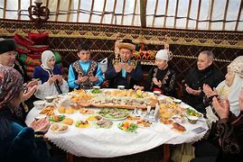
Konakasy is a custom associated with treating a guest. The Kazakh people have been famous for their hospitality since ancient times. Kazakhs have always reserved all the most delicious things for guests. The guests were divided into three types. "Arnayy konak" is specially invited, "kudayy konak" is a casual traveler, "kydyrma konak" is an unexpected guest. It should be noted that if the owner of the house for some reason refused to observe the custom of konakasa, penalties could be applied against him (in ancient times).
Konakkade is a tradition according to which the owner of the house has the right to ask the guest to sing a song or play a musical instrument. Conaccade is a test of the guest's art, as well as a guarantee of a fun feast.
Yerulik – if new settlers arrived in the village, a yerulik was arranged in their honor – a small holiday that allowed those who arrived to adapt to a new place faster. Also, the yerulik custom included assistance in the household arrangement of beginners. Neighbors provided them with firewood, drinking water, etc.
Toy dastarkhan is a special form of celebration organized for or during the holiday. In addition to gatherings at the table, during that dastarkhan, sports, music, song competitions (aitys), horse races are held.
Activity 5.
4. TRADITIONS AND CUSTOMS RELATED TO THE BIRTH AND UPBRINGING OF A CHILD
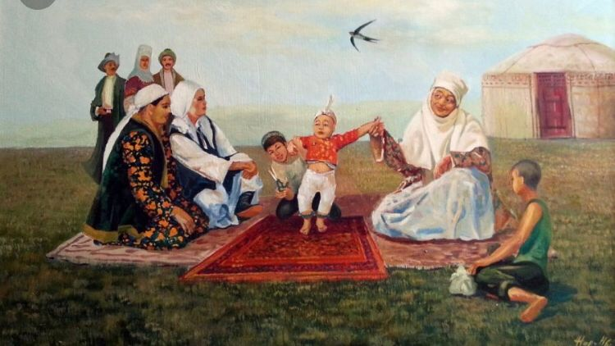
Shildehana is a celebration associated with the birth of a child.
Besikke salu, besik toy is a holiday arranged after the newborn is put in a cradle. As a rule, it is organized on the 3-5 day after the umbilical cord falls off in the baby.
Esim koyu, at koyu - the naming ceremony. It can be held as part of the shildehana holiday, or during a celebration dedicated to putting a newborn in a cradle. The execution of the rite is entrusted to the most respected people, who, among other things, bless the baby.
Kyrkynan shygaru is a rite performed on the fortieth day after the birth of a child. Includes: bathing the baby in 40 tablespoons of water, as well as the first haircut of hair and nails.
Tusau kesu - according to Kazakh custom, on the day when the child took his first steps, the oldest and most respected person in the village was invited to the yurt. He had to cut with a knife the special ropes entangling the child's legs (cutting the fetters). This was done so that in the future the baby could walk beautifully and run fast.
Sundetke otyrgyzu - the rite of circumcision. The ceremony is held when the child turns 5-7 years old. On this day, parents call a mullah to the yurt, who conducts this procedure. For this, the mullah receives a generous reward. On the occasion of the sundetke otyrgyzu, a big holiday is organized, to which all relatives and friends are invited. Those who come to the party make generous gifts to the hero of the occasion and his parents.

Activity 6.
5. TRADITIONS AND CUSTOMS RELATED TO MARRIAGE

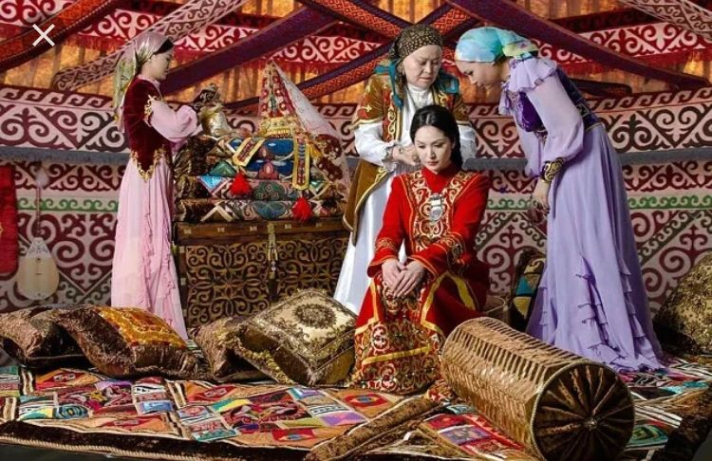

According to the Kazakhs, marriage between relatives up to the seventh generation is prohibited, such a taboo helps to prevent blood-related mixing and, as a result, has a favorable effect on the health of future offspring.
In addition, in former times there was a judgment that early marriages help to keep young people from indecent acts, and are also prerequisites for the birth of healthy children. Therefore, girls were married at the age of 13 - 14. However, today, the tradition of early marriages is not practiced in Kazakhstan.
Any wedding ceremony in the Kazakh society is anticipated by kudalyk (matchmaking). On the eve of the wedding, matchmakers come to the bride's house. Their task is to negotiate with the girl's closest relatives about her marriage. During the matchmaking, the bride's father receives gifts from the guests, which are a kind of deposit.
If the negotiations are successful, the father, in turn, hands the main matchmaker a robe. This custom is called "shege shapan". Preparation of "kuyryk bauyr", a dish made from liver and fat fat, also testifies to the successful completion of matchmaking.
The next stage of the holiday is seeing off the bride "kyz uzatu". In the evening before the ceremony, matchmakers come to the girl's house again. The number of visitors should not be even (5-7 people). Early in the morning, the bride and her matchmakers are sent to the groom's house. The farewell procedure is accompanied by the performance of the Kazakh ritual song "Zhar-Zhar".
The solemn ceremony of meeting the bride is called kelin tysiru. The main element of kelin tysiru is the performance of a traditional song of instructions and wishes – "Betashar".
In ancient times, when the Kazakhs practiced a nomadic lifestyle, the dwelling of the newlyweds (yurt) was located behind the house of the groom's parents. According to tradition, the bride had to cross the threshold of the yurt first, and she had to do it with her right foot.
Also during the wedding ceremony, the newlyweds should jointly drink a vessel with water in which sugar and salt are dissolved. According to the legend, this ritual is the guarantor of a happy family life.
No less interesting in the complex of wedding events is the ceremony of unwinding the bride's braid, followed by bifurcation. Two braids on the bride's head symbolize the end of loneliness and the beginning of married life.

Activity 7
6. THE OLDEST CUSTOMS OF THE KAZAKH PEOPLE

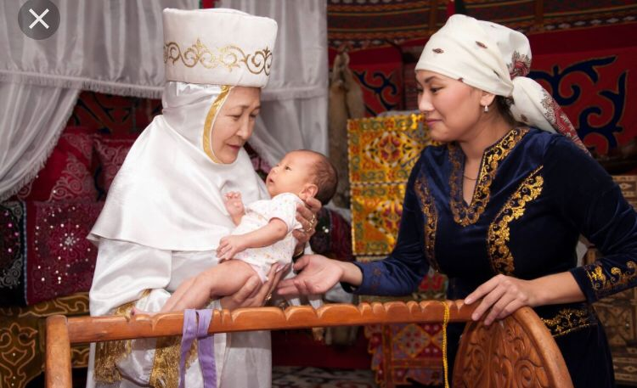

Tugan zherge aunatu – according to this custom, a person who has lived far from his native places for a long time should be rolled in the ground upon returning to his homeland. Briefly, the meaning of this action can be explained by the following proverb – "we are all children of our native land."
Auzyna tukirtu – literally the name of this ritual translates as "spit in the mouth". The ancient Kazakhs had a belief that with a drop of saliva passed to a child by a brave batyr, a popular akyn or speaker, a piece of the gene of giftedness of this person will pass to the baby. Thanks to this, this child will be lucky in the future.
Ashamayga mingizu is a rite according to which a 6-7–year-old boy was supposed to be given a horse and a kamcha. Such a ritual was a kind of "initiation", after which the child was proclaimed a horseman. On this day, the old men blessed the young rider for feats of arms. After that, the parents arranged a small toy (holiday) in honor of their son.
Bastangy is an ancient analogue of modern youth parties. Traditionally, such celebrations were held immediately after the departure of adults. During the bastanga, the guests, as a rule, expressed only one wish - that luck accompanied the travelers on the road and the disease did not overtake them.

To enhance your vocabulary related to the customs of Kazakhstan, here are some exercises focusing on key terms and phrases associated with Kazakh culture:

Activity 8:
Match each vocabulary word with its correct definition or description.

Vocabulary Words:
- Nomadic
- Hospitality
- Yurt
- Nauryz
- Dombra

Definitions/Descriptions:
a) Traditional Central Asian musical instrument.
b) Portable, circular tent traditionally used by nomadic peoples.
c) Celebration of the New Year and the coming of spring in Kazakhstan.
d) Practice of welcoming and treating guests with generosity and respect.
e) Way of life involving seasonal movement of people with livestock.

Activity 9. Fill in the Blanks:
Fill in the blanks with the appropriate words related to Kazakh customs.

a) Kazakh ___________ involves serving tea and traditional snacks to guests.
b) Many Kazakhs celebrate the festival of ___________ in March.
c) The ___________ is a traditional dwelling used by nomadic people.
d) Kazakh music often features the use of the ___________, a string instrument.
e) The ___________ heritage of Kazakhstan is reflected in its cultural practices.

Activity 10. Word Association:
Write down words or phrases that come to mind when you think about Kazakh customs and culture.

Example associations:
- Kazakh cuisine
- Traditional music and dance
- Family values
- Nomadic lifestyle
- Festivals and celebrations
Activity 10. Usage in Sentences:
Construct sentences using the following vocabulary words related to Kazakh customs:

Vocabulary Words:
- Kumis
- Beshbarmak
- Eagle dance
- Family ties

Example Sentences:
- Kumis is a traditional Kazakh drink made from fermented mare's milk.
- Beshbarmak, a dish of boiled meat and noodles, is a staple of Kazakh cuisine.
- The eagle dance is a captivating traditional performance in Kazakh culture.
- Kazakhs place great importance on maintaining strong family ties.

These exercises should help reinforce your understanding of vocabulary related to the customs and traditions of Kazakhstan. Feel free to explore more about Kazakh culture through reading, videos, or conversations with native speakers to further enrich your vocabulary and knowledge.

12. CULTURAL AND NATIONAL HOLIDAY

Activity 1
Read and translate the text

Kazakhstan, the ninth largest country in the world, embraces many nationalities who have contributed to the evolution of the nation’s public holidays.
Below we have listed the cultural and national Kazakh holidays:
March 21-23, Nauryz
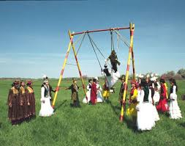
Nauryz (Navruz), the holiday of the spring equinox, is observed in Kazakhstan and many other eastern nations as a symbol of spring, new beginnings, prosperity and unity.
The history of the holiday has its roots in the pagan rituals of the pre-Islamic period. In former times, Nauryz was called the "Great Day of the Ulus (Nation)" and it was believed that the more elaborate the celebration, the more prosperous the coming year would be.
Nauryz remains one of the most important national holidays of Kazakhstan, where Kazakhs celebrate in their own unique way as they seek to preserve as many traditions passed down from their ancestors as possible. It is believed that on the eve of the holiday all debts should be paid, quarreling should cease and the whole house be put in order.
Each family prepares a special feast, or dastarkhan. The main dish is navruz-kozhe, a rich soup traditionally made from 7 ingredients - milk, meat, butter, millet, rice, raisins and corn. Although the precise ingredients may vary (one can add cottage cheese instead of rice, for example), the number of ingredients used in the dish must always be 7, the number of luck and prosperity considered essential for the Navruz celebration. In ancient times navruz-kozhe was poured into seven bowls to feed 7 persons. It was important to invite 7 guests to your home on this day and for each person to visit 7 houses in turn.
Today Nauryz reflects the implementation of centuries-old folk traditions with modern culture. People celebrate with concerts and theatrical performances, a variety of tasty national dishes, traditional sports and games and lively intellectual battles of the akyns, or Kazakh folk poets.

May 7, Defender of the Fatherland Day
On May 7, 1992, a decree was signed to create the National Armed Forces of the Republic of Kazakhstan, and in 2012 the day was declared a national holiday. On this day, the people of Kazakhstan pay tribute to their veterans, who are presented with awards and honorary military titles by the authorities. Open-air concerts are typically held at city squares, along with military parades and demonstrations of elaborate military exercises.

May 9, Victory Day
The Allied defeat of Nazi Germany is celebrated in Kazakhstan on May 9 in touching displays of respect and honor toward those who lost their lives in World War II. More than a million soldiers from Kazakhstan fought in the ranks of the Soviet army during the war, with more than a hundred thousand Kazakhstanis awarded for their courage and heroic acts.
Massive celebrations are organized in the country on this day, including military parades and the Immortal Regiment March comprised of a grand procession of the war heroes’ grateful descendants. "Garlands of Glory" are placed at the graves of the deceased and at the monument of Otan Korkaushylar (Defenders of the Fatherland) in capital city Astana. Festive concerts and gatherings are organized for the war veterans in a show of gratitude for their deeds.

July 6, Capital City Day
The city of Almaty served as the first capital of Kazakhstan until July 6, 1994, when it was moved for strategic purposes to the central city of Akmola. In 1998, its name was changed to Astana, and in 2019 the city was renamed Nur-Sultan, in honor of the first president of Kazakhstan, Nursultan Nazarbayev, whose birthday is also July 6. On September 17, 2022, President Tokayev signed a decree renaming the capital city back to Astana. The decree entered into force from the day of its publication.
Capital City Day is celebrated on a grand scale, particularly in Astana itself, where fireworks, concerts, theatrical performances, children’s events and city exhibitions may be enjoyed by residents and visitors.

Date varies, Eid al-Adha
Eid al-Adha is the culmination of Hajj, the annual Islamic pilgrimage to Mecca, and is celebrated on the 10th day of the 12th month of the Islamic lunar calendar. One of the most important significant religious holidays in Kazakhstan, it celebrates the joy of life and wellbeing while encouraging everyone to reach out to their neighbors. A key element of the holiday is the sacrifice of a cow, ram or camel, whose meat is then distributed to those in need. Charitable funds for the poor are likewise organized in the mosques.
In Kazakhstan, Eid al-Adha traditionally begins with the morning prayer, known as ait-namaz. During the day, people visit friends and family members, exchange gifts and treats and participate in celebrations and charity events. Festivals are held throughout the country which unite not only Muslims but local people of other faiths.

August 30, Constitution Day
Constitution Day in Kazakhstan recognizes the basic principles of the state, which were approved at a national referendum on August 30, 1995. According to the first article of the Constitution, Kazakhstan asserts itself as a democratic, secular and legal state whose highest values are the life and basic human rights of the individual.
The capital offers residents and guests an array of festive programs. Kazakh and foreign pop star concerts are held in open-air and enclosed venues. At a sports festival held on the city square, everyone can take part in tug-of-war, streetball, mini-football, the ancient nomadic game of asyk atu and other competitions. In city parks, entertainment programs for children are organized, and in the evening colorful fireworks illuminate the city.

October 25, Republic Day
Republic Day was included in the list of public holidays in 2001, but in 2009 it was removed from the calendar of official dates.
Speaking at the first meeting of the National Kurultai, President of Kazakhstan Kassym-Zhomart Tokayev proposed to restore the Republic Day as a national holiday.
Republic Day is celebrated on October 25. Concerts, scientific conferences, creative contests, sports competitions, patriotic, volunteer and charity events are held in honor of the Republic Day in the regions of Kazakhstan.

December 16-17, Independence Day
On December 16, 1991, a new era began in the history of Kazakhstan when the country declared its independence from the Soviet Union. Kazakhstanis celebrate this holiday, counted among the most important public holidays in Kazakhstan, with gusto. On the eve of the holiday, distinguished cultural and political figures are awarded with honors. Top state officials participate in concerts and festivals held throughout the republic, with the holiday ending in a huge display of fireworks.

To expand your vocabulary related to cultural and national holidays in Kazakhstan, here are some engaging exercises focusing on key terms and phrases associated with Kazakh celebrations:

Activity 2 Match the Words:
Match each vocabulary word with its correct definition or description.

Vocabulary Words:
- Nauryz
- Aitys
- Kyz Kuu
- Shashu
- Besik Toi

Definitions/Descriptions:
a) Traditional Kazakh holiday celebrating the New Year and the arrival of spring.
b) A poetic duel or contest of improvised oral poetry.
c) A traditional Kazakh horseback game where a man chases a woman on horseback.
d) The act of cradle-rocking ceremony for a newborn.
e) A festive dish often prepared during special occasions.

Answers:
- Nauryz (a)
- Aitys (b)
- Kyz Kuu (c)
- Besik Toi (d)
- Shashu (e)

Activity 3. Fill in the Blanks:
Fill in the blanks with the appropriate words related to cultural and national holidays in Kazakhstan.

a) ___________ is a popular traditional horseback game played during Kazakh celebrations.
b) During Nauryz, people exchange gifts and prepare special ___________ dishes.
c) Aitys is a traditional form of poetic ___________.
d) Besik Toi is a ceremony celebrating the ___________ of a newborn child.

Answers:
a) Kyz Kuu
b) festive
c) competition
d) birth

Activity 4. Word Association:
Write down words or phrases that come to mind when you think about cultural and national holidays in Kazakhstan.

Example associations:
- Nauryz
- Traditional games
- Poetry contests
- Festive food
- Community gatherings
Activity 5. Usage in Sentences:

Construct sentences using the following vocabulary words related to Kazakh cultural holidays:
Vocabulary Words:
- Shashu
- Nauryz
- Aitys
- Besik Toi

Example Sentences:
- Nauryz is celebrated with joyous gatherings and the sharing of traditional dishes.
- Aitys competitions showcase the poetic talents of Kazakh people.
- Shashu is a cherished part of Kazakh cultural heritage, involving communal feasting.
- The Besik Toi ceremony symbolizes the beginning of a child's life journey in Kazakh tradition.
These exercises are designed to help you familiarize yourself with vocabulary related to cultural and national holidays in Kazakhstan. As you continue to explore Kazakh culture, consider researching more about these celebrations and their significance to deepen your understanding and vocabulary further.

13. MY KNOWLEDGE

Activity 1: a) Read the text and write down the words related to the topic Education

Student’s Life
In two weeks I shall finish my first year at Cambridge. Let me tell you something about student's life and my impressions of it.
The students are mainly English, but there are many others. Particularly so in the block of rooms in which I live, for my neighbours include a Chinese studying Law, an Indian studying English, Canadian studying History and a Frenchman studying Science
The rooms have a pleasant outlook over the College gardens. There is a very small gas-stove on which we make coffee or tea. It is a popular tradition here to invite friends in the afternoon for tea, hot buttered toast and jam. To each room there is a manservant who with a womenservant, known as a "bedder", keep it clean.
In the old days when Colleges were religious institutions the students were clergymen (священник) and their life was much more strict and disciplined than now.
Friendship with young ladies was not allowed and the only women inside the college were washerwomen. The legend is that these had to be "old and ugly".
The students eat their meals in the College dining-hall. At some Colleges there is an interesting tradition. It is known as "sconing". If a student comes late to dinner or he is not correctly dressed, or if he breaks one of the laws of behaviour, then the senior student orders him to be "sconed".
A large silver cup, known as "scone cup", filled with beer is brought and placed in front of him and he must drink it in one attempt without taking the cup from his lips (it holds two and a half pints, or 1.5 litres). If he can do it, then the senior student pays for it, if not, the cup is passed and the student who has been "sconed" must pay for it. In general the discipline is not strict.

b) Answer the questions:
1. Is Cambridge a multinational university? Can you prove it?
2. What tradition is popular among the students at Cambridge?
3. What are students "sconed" for?

c) Agree or disagree with these sentences:
1. There is a very small microwave oven on which the students make coffee or tea.
2. To each room there is a manservant who with a womenservant, known as a "bedder", keep it clean.
3. In the old days when Colleges were religious institutions the students were clergymen (священник) and their life was much more free than now.

Activity 3. а) Read the text and the questions:
1. What do the so-called "Bulldogs" do if a student whom they come up to runs away?
2. What students' societies are there at Cambridge and which is the most popular one?

b) Read the text and write down the words related to the topic Education
The students can stay out till twelve o'clock. Each evening a Proctor with two assistance, called "Bulldogs", walks about the town keeping an eye on the students' pehaviour. If he sees a student breaking a rule he will come up to him and say, "Are you a member of the University, sir?", and if a student runs away, then the
"Bulldogs" run after him, and if they catch him (they are chosen, it is said, because they are good runners), fine him.
Apart from fines a student may be dismissed from the University for one term.
We attend our lectures in the morning and in the afternoon we are free. I usually work in my room or take part in some sport. The most popular sport is rowing There are over a hundred societies and clubs. There are religious societies and society for those who don't believe, political, sporting and dramatic societies. These is even one for people with beards. Perhaps the most popular is the Debating Society at which students debate political and other questions with famous politicians and writers
The walks into the country, the talks, the games and the work, the traditions and the customs - all are part of the students' life which would be poorer if any of them was lost.

Activity 4. Read the text and write down the words related to the topic Education

WHY WE CHOSE THE LUMUMBA FRIENDSHIP UNIVERSITY
The People's Friendship University brings together young people of different countries. The University started functioning with a handful of students from Asia, Africa, Latin America and also from Russia. But each academic year brought new entrants, and now it has more than four thousand students. The number of boys and girls who wish to enter the University is very high. I believe that over eight thousand applications are received from about six hundred vacancies. This shows the University's growing popularity and prestige, why do so many young men wish to enter this University? Let us try and analyse the reasons and we shall see clearly that this University fully deserves its popularity.
I believe everybody knows that education is free in Russia. Foreign students, too, receive free education here. They pay nothing. Furthermore, every student gets a monthly grant.
The University is staffed by highly qualified teachers. Professors and lecturers are always ready to give all sort of help not only in the classroom but also outside it. A student may come to them whenever he is in difficulties. Groups are small. This raises the quality of teaching. Relations between teachers and students are friendly.
Students may use the University library. Books are given without charge, and students may keep them till they pass their examinations. The students don't have to buy books, the library has practically all the books they need. It gets magazines and journals from many different countries. It is really a pleasure to see boys and girls from different countries studying together in the comfortable reading-room.
Here's a set of vocabulary words related to the theme of education:

1. Pedagogy: The method and practice of teaching, especially as an academic subject or theoretical concept.

2. Curriculum: The subjects comprising a course of study in a school or college.

3. Didactic: Intended to teach, particularly in having moral instruction as an ulterior motive.

4. Edification: The process of instruction or improvement of a person morally or intellectually.

5. Learning: The acquisition of knowledge or skills through study, experience, or being taught.

6. Instruction: The act of teaching or providing knowledge.

7. Tutoring: Individualized teaching, typically outside of regular classroom instruction.

8. Scholarship: Academic study or achievement; a grant or payment made to support a student's education.

9. Academic: Related to education and scholarship, particularly in a formal setting like schools or universities.

10. Intellectual: Relating to the ability to think and understand ideas at a high level; engaging in academic pursuits.

11. Literacy: The ability to read and write; competence or knowledge in a specified area.

12. Educationalist: A person who is knowledgeable about theories and methods of teaching and learning.

13. Schooling: Formal education received at a school, including primary, secondary, or higher education.

14. Pedagogical: Relating to the methods and theory of teaching, especially as an academic subject.

15. Mentorship: Guidance provided by a mentor, typically an experienced or knowledgeable person, to someone less experienced.

16. Experiential Learning: Learning through hands-on experience and reflection, rather than through direct instruction.

17. Enrichment: Providing additional or enhanced educational experiences beyond the standard curriculum.

18. Critical Thinking: The objective analysis and evaluation of an issue in order to form a judgment.

19. Empowerment: The process of enabling individuals to gain control over their lives through education and self-awareness.

20. Inquiry: The act of asking for information or investigating; a method of learning through questioning and exploration.

14. MY UNIVERSITY

Activity 1 A) Read the text and translate

The Role of Universities in Shaping Tomorrow's Leaders.

In today's rapidly evolving world, universities play a pivotal role in shaping the leaders of tomorrow. Beyond imparting knowledge and skills, universities serve as hubs of innovation, critical thinking, and societal advancement.
At the heart of every university are its dedicated faculty members, whose expertise spans various disciplines. These professors not only deliver lectures but also mentor students, guiding them in their academic pursuits and encouraging intellectual curiosity. Through research endeavors, they push the boundaries of human understanding and contribute to solutions for global challenges.
Students, the lifeblood of any university, come from diverse backgrounds and cultures. Within the university's vibrant community, they engage in lively debates, collaborate on projects, and form lifelong friendships. Beyond the classroom, extracurricular activities and student organizations provide opportunities for personal growth and leadership development.
Universities are also engines of innovation, fostering entrepreneurship and creativity. From groundbreaking research in science and technology to initiatives in the arts and humanities, universities serve as catalysts for progress. Start-up incubators and technology transfer offices facilitate the transformation of ideas into real-world impact, driving economic growth and social change.
Moreover, universities have a profound impact on society at large. Through community outreach programs and partnerships with local organizations, they address pressing issues such as healthcare disparities, environmental sustainability, and social justice. By engaging with communities both near and far, universities fulfill their mission of knowledge dissemination and service to humanity.
As we look to the future, the role of universities will only continue to expand. In an era defined by complexity and uncertainty, universities remain beacons of hope, empowering individuals to navigate an ever-changing world with wisdom, compassion, and resilience. Together, as students, faculty, and alumni, we forge a path towards a brighter tomorrow, guided by the enduring values of education and enlightenment.

B) 1. Vocabulary Matching:
Match the words from the text with their definitions:
- 1. Faculty
- 2. Innovation
- 3. Extracurricular
- 4. Catalyst
- 5. Outreach

Definitions:
- A. Members of the teaching staff at a university or college.
- B. The introduction of new ideas, methods, or products.
- C. Activities or interests pursued outside the regular academic curriculum.
- D. A substance that increases the rate of a chemical reaction without itself undergoing any permanent chemical change.
- E. Efforts to reach out to the community or groups outside of the university.

Activity 2. True or False:
Determine if the following statements are true or false based on the text:
- a. Universities primarily focus on delivering lectures and conducting research. (False)
- b. Students from the same background and culture often come together in university communities. (False)
- c. Extracurricular activities play a minor role in personal growth and leadership development. (False)
- d. Universities contribute to economic growth by fostering innovation and entrepreneurship. (True)
- e. Community outreach programs are not part of the university's mission. (False)

Activity 3. Fill in the Blanks:
Fill in the blanks with the appropriate words from the text:
- a. The _______________ members at our university are renowned for their expertise in various fields.
- b. The university's commitment to _______________ has led to numerous breakthroughs in science and technology.
- c. Students engage in a wide range of _______________ activities, from sports to community service.
- d. Universities serve as _______________ for progress, driving innovation and social change.
- e. Through _______________ programs, universities address societal issues and promote positive change.

Activity 4. Discussion Questions:
Discuss the following questions based on the text:
- a. What are some examples of extracurricular activities that can contribute to personal growth and leadership development?
- b. How do universities foster innovation and entrepreneurship among students and faculty?
- c. In what ways can universities strengthen their community outreach efforts to address pressing societal issues?
- d. How might the role of universities in shaping tomorrow's leaders evolve in the future, given the changing global landscape?
- e. What values do universities uphold, and how do these values influence their impact on society?

These exercises aim to reinforce comprehension of the text while also encouraging critical thinking and discussion.

Vocabulary exercises focused on the theme of "university":

Activity 5. Word Definitions:
Provide definitions for the following university-related terms:
- 1. Lecture
- 2. Dormitory
- 3. Professor
- 4. Curriculum
- 5. Scholarship
- 6. Thesis
- 7. Registrar
- 8. Alumni

Activity 6. Fill in the Blanks:
Complete the sentences with the appropriate university-related words:
- a. The _______________ is responsible for keeping academic records and registering students for classes.
- b. Professor Johnson will deliver a fascinating _______________ on quantum mechanics tomorrow.
- c. Many students live in the _______________ during their first year of university.
- d. Sarah received a _______________ to help cover the cost of her tuition.
- e. Alex is working hard on his _______________ paper, which explores the effects of climate change.
- f. The _______________ includes a variety of courses designed to provide a well-rounded education.
- g. After graduation, John joined the university's _______________ association to stay connected with fellow graduates.
- h. Dr. Patel has been a _______________ of economics at the university for over twenty years.

Activity 7. Word Search:
Find the following university-related words hidden in the grid:

U N I V E R S I T Y L F
A L U M N I E R S C T E
L O C T I T U I T I O N
T T E R Y S C H O L A R
I E P R O F E S S O R E
O N L E T E U R R O D T
N R R I C U L U M D H N
T R T T E I L E C T U R

Words to find: University, Professor, Curriculum, Lecture, Alumni, Scholarship

Activity 8. Sentence Completion:
Complete the following sentences with the appropriate words from the list:
- a. The _______________ offered by the university is highly regarded in the field of engineering.
- b. Lisa attended every _______________ on European history to prepare for her exam.
- c. The _______________ oversees the academic records and registration process for students.
- d. After completing his degree, Mark joined the _______________ association to network with other graduates.
- e. Maria applied for a _______________ to help finance her studies in medicine.

Activity 9. Matching Exercise:
Match the university-related terms with their definitions or descriptions:
- 1. Lecture
- 2. Curriculum
- 3. Registrar
- 4. Scholarship
- 5. Alumni
- 6. Thesis
- 7. Dormitory
- 8. Professor

Definitions/Descriptions:
- A. A document presenting a student's research findings, typically required for a higher degree.
- B. A financial award given to students to help cover the cost of education.
- C. A place where students reside, typically on or near campus.
- D. An academic staff member who teaches courses and conducts research at a university.
- E. A series of planned courses constituting a complete course of study in a particular subject.
- F. A formal presentation or speech given by a lecturer or professor.
- G. An official responsible for maintaining student records and managing registration.
- H. Individuals who have graduated from a particular school, college, or university.

15. FUTURE PROFESSION

Activity 1
A) Read the text and translate

Navigating the Path to Your Future Profession

In the journey of life, the choice of a profession holds paramount importance, shaping not only one's career but also one's identity and sense of purpose. As we stand at the threshold of the future, the landscape of professions is undergoing rapid transformation, driven by technological advancements, shifting global dynamics, and evolving societal needs.
The traditional notion of a linear career path is giving way to a more dynamic and multifaceted approach. Gone are the days of lifelong employment in a single profession; instead, individuals are embracing portfolio careers, characterized by a diverse range of roles and experiences. The gig economy offers opportunities for flexibility and autonomy, allowing individuals to explore multiple passions and interests simultaneously.
At the heart of this transformation lies the need for adaptability and lifelong learning. In an era marked by automation and artificial intelligence, the skills required for success are constantly evolving. The ability to learn, unlearn, and relearn becomes indispensable, enabling individuals to stay ahead of the curve and thrive in an ever-changing job market.
Moreover, the concept of work itself is being redefined, with emphasis shifting from mere financial remuneration to personal fulfillment and social impact. The pursuit of meaningful work, aligned with one's values and aspirations, takes precedence over traditional notions of success. As the boundaries between work and life blur, individuals seek professions that allow them to make a positive difference in the world while maintaining a sense of balance and well-being.
In this era of unprecedented opportunity and uncertainty, the path to finding one's future profession is marked by exploration, experimentation, and resilience. It requires a willingness to step outside comfort zones, embrace failure as a learning opportunity, and pivot in response to changing circumstances. Mentorship and networking play crucial roles, providing guidance, support, and access to new opportunities.
As we embark on this journey, let us remember that our future profession is not merely a destination but a reflection of who we are and who we aspire to be. It is a manifestation of our passions, talents, and values, guiding us towards a life of fulfillment, purpose, and contribution to the greater good.
In the pursuit of our future profession, may we remain open to possibility, curious in our exploration, and resilient in the face of challenges. For in the convergence of passion, purpose, and perseverance lies the promise of a future rich with meaning, impact, and endless opportunities for growth and fulfillment.
---
This text explores the evolving landscape of professions in the context of the future, emphasizing adaptability, lifelong learning, and the pursuit of meaningful work.

Activity 2
Exercises based on the text "Navigating the Path to Your Future Profession":

1. Vocabulary Matching:
Match the words from the text with their definitions:
- 1. Portfolio career
- 2. Adaptability
- 3. Fulfillment
- 4. Resilience
- 5. Exploration

Definitions:
- A. The ability to adjust to new conditions or changes.
- B. Having a diverse range of roles and experiences rather than a single traditional career path.
- C. The feeling of satisfaction and contentment derived from one's work.
- D. The capacity to recover quickly from difficulties; toughness.
- E. The act of searching or investigating to discover new possibilities or opportunities.

Activity 3
True or False:
Determine if the following statements are true or false based on the text:
- a. In the future, people are expected to have lifelong employment in a single profession. (False)
- b. Adaptability is not important in today's job market. (False)
- c. The pursuit of meaningful work is becoming less important. (False)
- d. Networking plays a minor role in finding one's future profession. (False)
- e. Resilience involves the ability to recover quickly from challenges. (True)

Activity 4
Fill in the Blanks:
Fill in the blanks with the appropriate words from the text:
- a. In the future, individuals are embracing _______________ careers, which offer a diverse range of roles and experiences.
- b. The key to success in today's job market is _______________ - the ability to adjust to new conditions and challenges.
- c. Many people seek professions that provide a sense of _______________, where they can find satisfaction and contentment in their work.
- d. Building _______________ is essential for navigating the path to your future profession, as it provides guidance, support, and access to new opportunities.
- e. The journey to finding your future profession involves _______________ - exploring different possibilities and opportunities to discover what aligns with your passions and values.
Activity 5. Discussion Questions:
Discuss the following questions based on the text:
- a. What are the advantages and disadvantages of having a portfolio career?
- b. How can individuals cultivate adaptability in their professional lives?
- c. Why is meaningful work important, and how can individuals identify professions that align with their values and aspirations?
- d. Share examples of how resilience has played a role in your own career journey or that of someone you know.
- e. How can mentorship and networking contribute to finding one's future profession?

These exercises aim to reinforce comprehension of the text while also encouraging critical thinking and discussion about career exploration and development.

Activity 6
1. Word Matching:
Match the following words related to future professions with their definitions:
- 1. Automation
- 2. Gig economy
- 3. Remote work
- 4. Specialization
- 5. Entrepreneurship
- 6. Flexibility
- 7. Sustainability

Definitions:
- A. The ability to adapt to changing circumstances or requirements.
- B. The practice of working independently on short-term contracts or freelance work.
- C. The process of introducing machines or technology to perform tasks that were previously done by humans.
- D. The pursuit of activities aimed at generating revenue or profit through innovation and risk-taking.
- E. Focusing on a specific area or field of expertise within a profession.
- F. Working from a location other than the traditional office environment, often enabled by technology.
- G. Meeting the needs of the present without compromising the ability of future generations to meet their own needs.

Activity 7. Fill in the Blanks:
Fill in the blanks with the appropriate vocabulary words:
- a. The _______________ of artificial intelligence and robotics is reshaping many industries, leading to changes in job roles.
- b. In the _______________, individuals often work on multiple projects simultaneously, enjoying the freedom to set their own schedules.
- c. _______________ is becoming increasingly common, allowing employees to work from home or other remote locations.
- d. _______________ requires individuals to develop expertise in a specific area to remain competitive in the job market.
- e. Many young professionals are drawn to the idea of _______________, seeking to create innovative solutions to societal challenges.
- f. The future of work will require a high degree of _______________, as job roles and requirements continue to evolve.
- g. Companies are placing greater emphasis on _______________ in their operations, considering environmental and social impacts alongside financial success.

Activity 8. Word Search:
Find the following future profession-related words hidden in the grid:
```
F L E X I B I L I T Y Y
I S U S T A I N A B I L I
G R E M O T E W O R K N A
E E N T R E P R E N E U R S
N A U T O M A T I O N M T
T A S P E C I A L I Z A T I
I O N G I G E C O N O M Y
O R K Y S P L E D H F E E
N A W E S H C E O T A R I
```

Words to find: Flexibility, Sustainability, Remote Work, Entrepreneurship, Automation, Specialization, Gig Economy

Activity 9:
Complete the following sentences with the appropriate words from the list:
- a. With advancements in technology, _______________ is becoming increasingly common, enabling employees to work from anywhere with an internet connection.
- b. The _______________ of machines and AI has led to concerns about the future of certain professions that may be automated.
- c. In the _______________, individuals often take on multiple short-term contracts or freelance projects rather than traditional full-time employment.
- d. _______________ requires individuals to develop deep expertise in a specific area, enhancing their value in the job market.
- e. Many young professionals are drawn to _______________, as it offers opportunities to pursue innovative ideas and create positive change.

These exercises should help reinforce vocabulary related to future professions while also providing opportunities for word recognition and comprehension.

Writing a CV (Curriculum Vitae) is an important step in applying for jobs or academic opportunities. Here are some general rules and guidelines to follow when writing a CV:

1. Contact Information:
- Include your full name, address, phone number, and professional email address at the top of the CV.
- Make sure your contact information is clear, accurate, and up-to-date.
2. Personal Statement or Objective (Optional):
- Consider including a brief personal statement or objective at the beginning of your CV.
- This statement should highlight your career goals, skills, and what you can bring to the position or organization.
3. Professional Summary (Optional):
- Instead of a personal statement, you may include a professional summary highlighting your key achievements, skills, and experiences relevant to the position.
4. Education:
- List your educational background in reverse chronological order (most recent first).
- Include the name of the institution, degree earned, major or field of study, and graduation date.
- You can also include relevant coursework, academic honors, and GPA if it's impressive.
5. Work Experience:
- List your work experience in reverse chronological order, starting with your most recent job.
- Include the job title, name of the company or organization, location, and dates of employment.
- Provide a brief description of your responsibilities, accomplishments, and achievements in each role.
- Use action verbs and quantify your achievements whenever possible to demonstrate your impact.
6. Skills:
- Include a section listing your relevant skills, such as technical skills, language proficiency, certifications, and soft skills.
- Tailor your skills section to match the requirements of the job you're applying for.
7. Achievements and Awards (Optional):
- If applicable, include a section highlighting any relevant achievements, awards, or recognition you have received.
- This could include academic awards, professional certifications, or recognition from previous employers.
8. Volunteer Work or Extracurricular Activities (Optional):
- If relevant to the position, you can include a section highlighting any volunteer work, internships, or extracurricular activities you have participated in.
- Describe your roles and responsibilities in these activities and highlight any skills or experiences gained.
9. References:
- Generally, it's not necessary to include references on your CV unless specifically requested by the employer.
- Instead, you can write "References available upon request" at the end of your CV.
10. Formatting and Presentation:
- Keep your CV well-organized, clear, and easy to read.
- Use a professional font and maintain consistent formatting throughout the document.
- Avoid using excessive formatting, colors, or graphics that may distract from the content.
- Aim to keep your CV concise and focused, ideally no more than two pages in length.
11. Proofreading:
- Before submitting your CV, carefully proofread it to check for spelling and grammatical errors.
- Consider asking a trusted friend, family member, or mentor to review your CV for feedback.
Remember to tailor your CV for each job application, highlighting the most relevant skills and experiences that match the requirements of the position. By following these rules and guidelines, you can create a compelling CV that effectively showcases your qualifications and strengths to potential employers or academic institutions.

Пайдаланылған әдебиеттер

- Mascull, Bill. Business vocabulary in use. Cambridge: Cambridge University Press, 2004.
- McCarthy, Michael. Basic vocabulary in use. Cambridge: Cambridge University Press, 2001.
- Redman, Stuart. English vocabulary in use. Cambridge: Cambridge univ. press, 2001.
- Mascull, Bill. Business vocabulary in use. Cambridge: Cambridge univ. press, 2004.
- Mascull, Bill. Business vocabulary in use: Advanced. 2nd ed. Cambridge: Cambridge University Press, 2010.
- McCarthy, Mike. English vocabulary in use: Elementary. Cambridge: Cambridge University Press, 1999.
- Michael, McCarthy. English vocabulary in use: 100 units of vocabulary referenceand practice. Cambridge: Cambridge University Press, 1996.
- Lougheed, Lin. Words, more words an ways to use them. [ ]: Addison-Wesley Pub. Co., 1993.
- Mascull, Bill. Business vocabulary in use: Intermediate with answers. 2nd ed. Cambridge: Cambridge University Press, 2010.
- Michael, McCarthy. Test your English vocabulary in use: Elementary. 2nd ed. Cambridge: Cambridge University Press, 2010.
- https://www.grafiati.com/en/literature-selections/vocabulary-use/
- https://cse.buffalo.edu/~rapaport/refs-vocab.html
- https://pdfslide.us/documents/bibliography-lib-grammar-coursetheorybibliography-1-english-vocabulary-in.html?page=1#google_vignette

МАЗМҰНЫ

1.Me and my family
2. Modern young family
3. Relations between representatives of different generations
4. My house is my support
5. Human and his health
6. Sport in human life
7. Spending free time
8. World map
9. Geographical location and boundaries
10. Attractions of the city
11. The customs of the Republic of Kazakhstan and the country where the language is taught
12. Cultural and national holidays
13. My knowledge
14. My university
15. Future profession

Құрастырған : Muratova M.A. Artykbayeva F.I. Hamza B.N.

“USEFUL VOCABULARY WITH WORKSHEETS”

Педагогикалық білім беру бағдарлама бойынша білім алушыларына «Шетелі тілі» пәніне арналған оқу - әдістемелік құралы.

